

## SpinMaster – Intelligent Table Tennis Analysis

Final Year Project Report

Submitted by

Syed Abraash Ul Haq

(BSAI/ IT-21-336)

2269-2021

Mubashir Naveed

(BSAI/ IT-21-330)

2243-2021

Supervisor

Sir Aamir Hussain

In partial fulfillment of the requirements for the degree of

Bachelor of Science in Artificial Intelligence

2025

Faculty of Engineering Sciences and Technology

Hamdard Institute of Engineering and Technology

Hamdard University, Main Campus, Karachi, Pakistan

Certificate of Approval



Faculty of Engineering Sciences and Technology

Hamdard Institute of Engineering and Technology

Hamdard University, Karachi, Pakistan

This project “SpinMaster – Intelligent Table Tennis Analysis” is presented by “Syed Abraash ul-Haq” and “Mubashir Naveed” under the supervision of their project advisor and approved by the project examination committee, and acknowledged by the Hamdard Institute of Engineering and Technology, in the fulfillment of the requirements for the Bachelor degree of Artificial Intelligence/ Software Engineering.

Mr. Aamir Hussain In-charge FYP- Committee

(Project Supervisor)

|  |  |
| --- | --- |
| Dr. Shahid Munir Shah | Eng. Prof. Dr.Aamer Saleem |
| (Chairman Departing Of Computing) | (Dean, Fes |

Authors’ Declaration

We declare that this project report was carried out in accordance with the rules and regulations of Hamdard University. The work is original except where indicated by special references in the text and no part of the report has been submitted for any other degree. The report has not been presented to any other University for examination.

Dated:

Authors Signatures:

Syed Abraash ul-Haq

Mubashir Naveed

# Plagiarism Undertaking

We, Syed Abraash ul-Haq and Mubashir Naveed, solemnly declare that the work presented in the Final Year Project Report titled SpinMaster – Intelligent Table Tennis Analysis has been carried out solely by ourselves with no significant help from any other person except few of those which are duly acknowledged. We confirm that no portion of our report has been plagiarized and any material used in the report from other sources is properly referenced.

Dated:

Authors Signatures:

Syed Abraash ul-Haq

Mubashir Naveed

# Acknowledgments

Team members would like to acknowledge Hamdard Institute of Engineering and Technology for support of this Project, a highly appreciated achievement for us in the undergraduate level. It is obliged to our Supervisor Mr. Aamir Hussain who supported as our major advisor. It would like to express our gratitude for their keen guidance, sincere help and friendly manner which motivated us to do well in the project and makes it a reality. Many people, especially our classmates and team members themselves, have made valuable comment suggestions on this proposal which gave us inspiration to improve our project.

In conclusion, we are humbled and honored to have that privilege of collaborating with such a humble and talented group of individuals. The success of SpinMaster – Intelligent Table Tennis Analysis stands as testament to our collective capabilities and the remarkable achievements we can accomplish together.

Thank you all for your contributions, commitment, and unwavering support.

# Document Information

Table 1: Document Information

|  |  |
| --- | --- |
|  |  |
| Customer | Sports Players |
| Project Title | SpinMaster – Intelligent Table Tennis Analysis |
| Document | Final Year Project Report |
| Document Version | 1.0 |
| Identifier | FYP-035/FL24 Final Report |
| Status | Final Report |
| Author(s) | Syed Abraash Ul-Haq  Mubashir Naveed |
| Approver(s) | Mr. Aamir Hussain |
| Issue Date | 5-July-2025 |

Definition of Terms, Acronyms, and Abbreviations

|  |  |
| --- | --- |
| TERM | ABBREVIATIONS |
| FYP | Final Year Project |
| CNN | Convolutional Neural Network |
| AI | Artificial Intelligence |
| ANN | Artificial Neural Networks |
| DL | Deep Learning |
| ML | Machine Learning |
| KNN | K Nearest Neighbors |
| CV | Computer Vision |
| SVM | Support Vector Machine |
| IDE | Integrated Development Environment |
| V & V | Verification and Validation |
| PyTorch | A Python Framework |
| CSV | Comma Separated Values |
| UI | User Interface |

# 

# Abstract

Spin Master is an innovative system that improves table tennis training by analyzing spin types and player performance using pre-recorded gameplay videos. It uses computer vision and machine learning to help beginners and intermediate players understand and respond to different spins.

The system detects spin variations, ball trajectories, and player movements. It provides insights through a simple interface with performance metrics, feedback, and personalized training drills. Using pre-recorded footage ensures accurate and detailed analysis.

Players can track their progress over time and identify both strengths and weaknesses. Coaches can create customized training plans based on each player’s performance, leading to more focused and effective skill development.

Spin Master also encourages a data-driven training culture. It blends real-world practice with AI-powered analysis, helping players improve consistently and stay motivated throughout their training journey.

Designed for all skill levels, Spin Master is easy to use and highly adaptable. It helps users tackle key gameplay challenges like spin recognition and shot accuracy, setting a new standard for AI in sports analytics and transforming the future of table tennis coaching..

***Keywords:***

*Table Tennis, Spin Detection, Computer Vision, Machine Learning, Pre-Recorded Gameplay Analysis, Ball Trajectory Analysis, Training Drills, Player Improvement, Sports Analytics, Advanced Coaching Techniques*

Table of Contents

Contents

SpinMaster – Intelligent Table Tennis Analysis 1

Plagiarism Undertaking 2

Acknowledgments 3

Document Information 4

Abstract 6

CHAPTER 1 11

INTRODUCTION 11

1.1 Motivation 11

1.2 Problem Statement 11

1.3 Goals and Objectives 12

1.4 Project Scope 12

CHAPTER 2 13

RELEVANT BACKGROUND & DEFINITIONS 13

2.1 Introduction 13

2.2 Historical Background 13

2.3 Current Situation 13

2.4 Key terms and definitions 14

2.5 Importance of the Topic 14

CHAPTER 3 15

LITERATURE REVIEW & RELATED WORK 15

3.1 Literature Review 15

3.2 Related Work 16

CHAPTER 4 20

PROJECT DISCUSSION 20

4.1 Software Engineering Methodology 20

4.2 Project Methodology 20

4.3 Phases of the Project 21

4.4 Software/Tools that Used in Project 22

4.5 Hardware that Used in the Project 23

Chapter 5 24

IMPLEMENTATION 24

5.1 Proposed System Architecture 24

5.2 Design Diagram 25

5.3 Sequence Diagram 26

5.4 Use Case Diagram 27

5.6 Functional Specifications 28

5.7 Non-Functional Specifications 29

5.8 Testing 30

5.9 Purpose of Testing 31

5.10 Test Cases 31

Chapter 6 35

EXPERIMENTAL EVALUATIONS & RESULTS 35

6.1 Evaluation 35

6.2 Testbed 35

6.3 Result and Discussion 36

CHAPTER 7 37

CONCLUSION AND DISCUSSION 37

7.1 Strength of this Project 37

7.2 Limitations and Future Work 38

7.3 Future Work 39

7.4 Reasons for Failure – If Any 41

REFERENCES 42

APPENDICE 43

APPENDIX A. Project Proposal 43

APPENDIX B. Software Requirement Specification (SRS) 48

APPENDIX C. SOFTWARE DESIGN SPECIFICATIONS 58

APPENDIX D. OTHER TECHNICAL DETAIL DOCUMENTS 71

APPENDIX E. FLYER & POSTER DESIGN 79

APPENDIX F. COPY OF EVALUATION COMMENTS BY JURY FOR PROJECT – I 80

APPENDIX G User Manual Document 81

### List of Figures

Figure 3-1 TTNet Stroke Detection Pipeline ....................................................................................... 18

Figure 3-2 HomeCourt Shot Detection and Feedback Interface......................................................... 18

Figure 3-3 Tennis Swing Analyzer Feedback Screen ......................................................................... 19

Figure 3-4 SoccerMatch Event Recognition System........................................................................... 19

Figure 4-5 V-Model Methdology........................................................................................................ 21

Figure 4-6 Software Tools .................................................................................................................. 24

Figure 5-7 System Architecture .......................................................................................................... 25

Figure 5- 8 Design Diagram................................................................................................................ 26

Figure 5-9 Sequence Diagram ............................................................................................................ 27

Figure 5-10 Use Case Diagram ........................................................................................................... 28

Figure 12-1 Application UI-1 ............................................................................................................. 73

Figure 13-2 Application UI-2 ............................................................................................................. 74

Figure 14-3 Application UI-3 ............................................................................................................. 74

Figure 15-4 Application UI-4 ............................................................................................................. 75

Figure 16 Application UI-5 ................................................................................................................. 75

Figure 17 Application UI-6 ................................................................................................................. 76

Figure 18 Application UI-7 ................................................................................................................. 76

Figure 19 Application UI-8 ................................................................................................................. 77

Figure 20 Application UI-9 ................................................................................................................. 77

Figure 21 Flyer and Poster Design...................................................................................................... 79

### List of Tables

Table 3-1 Comparison Table .............................................................................................................. 20

Table 5-2 Test Case1 .......................................................................................................................... 33

Table 5-3 Test Case2 .......................................................................................................................... 33

Table 5-4 Test Case3 .......................................................................................................................... 34

Table 5-5 Test Case4 .......................................................................................................................... 34

Table 5-6 Test Case5 .......................................................................................................................... 35

# CHAPTER 1

# INTRODUCTION

In recent years, artificial intelligence has redefined the way sports are played, analyzed, and understood. From motion tracking in football to biomechanical assessments in tennis, AI-driven technologies are empowering athletes and coaches with previously unreachable insights. However, table tennis—a fast-paced and technique-intensive sport—still lacks accessible tools for performance analysis, especially for non-professional players.

This project, titled **SpinMaster,** presents an innovative approach to fill that gap by combining computer vision, pose estimation, and lightweight AI models. With nothing more than a recorded match video, players can receive meaningful performance feedback—highlighting their weak strokes, successful rallies, and areas for improvement. The system not only analyzes gameplay but also recommends personalized training modules based on a player's technical performance, making it a self-contained digital coach.

The following sections describe the motivation, challenges, objectives, and overall scope of this project.

## 1.1 Motivation

In the modern sports ecosystem, technology is rapidly transforming how players train, compete, and evolve. Table tennis, despite its global popularity and Olympic status, has traditionally relied on manual coaching techniques, with limited real-time feedback or data-driven insights available to amateur players. This creates a gap in skill development and performance analysis, especially for those without access to professional training environments.

The rise of computer vision, pose estimation, and deep learning opens new opportunities to democratize performance feedback. Inspired by the fusion of AI and sports science, this project—**SpinMaster**—was initiated to bridge that gap. It enables players to analyze their gameplay from simple video footage, gain real-time insights about their techniques (e.g., weak forehands, strong backhands), and receive tailored training suggestions based on those patterns. The motivation lies in creating an accessible, intelligent assistant for table tennis enthusiasts, from beginners to aspiring professionals.

## 1.2 Problem Statement

Traditional coaching lacks scalability, real-time analysis, and objectivity. Amateur table tennis players often struggle to identify and correct recurring issues in their gameplay due to the absence of affordable and intelligent feedback systems. Existing solutions are either too expensive, limited to elite training facilities, or require manual annotation and analysis.

## 1.3 Goals and Objectives

The core goal of this project is to design and develop an intelligent system—SpinMaster—that processes match videos and produces insightful, visual performance feedback for players.

Specific objectives include:

* Develop a user-friendly web interface for uploading table tennis match videos.
* Implement pose-based shot classification (forehand vs. backhand) using MediaPipe.
* Track player performance over the match and identify point winners based on shot success.
* Analyze success ratios of forehand/backhand shots for each player.
* Recommend relevant training modules via embedded tutorials (e.g., YouTube).
* (Optional/Future) Integrate TTNet or YOLOv8 for advanced ball tracking and stroke recognition.
* Enable session-based logins to track progress and user history.

## 1.4 Project Scope

This project focuses on surface-level analysis of table tennis matches using computer vision and deep learning. The scope is limited to:

* 1v1 standard table tennis match videos (recorded at 90-degree angle).
* Post match video processing (real-time may be future enhancement).
* Forehand and backhand classification via elbow pose estimation.
* Shot success determination through basic alternating logic.
* Feedback visualization and training suggestions via web-based dashboard.

**Out of scope (for now):**

* 3D tracking or biomechanics-level analysis
* Real-time tracking with frame-level ball physics
* Multi-player scenarios or coaching chatbots

Future extensions may include TTNet stroke recognition, YOLO-based ball detection, ranking-based performance comparison, or even gamified training feedback.

# CHAPTER 2

# RELEVANT BACKGROUND & DEFINITIONS

## 2.1 Introduction

Understanding the current capabilities and limitations of artificial intelligence (AI) in sports is crucial to contextualizing the significance of this project. This chapter presents a brief historical perspective on performance analysis in table tennis, followed by a look at how AI and computer vision are reshaping the field. It also defines key technical terms and establishes the relevance of developing a lightweight, automated match analysis tool like **SpinMaster**.

## 2.2 Historical Background

Historically, performance analysis in table tennis has been a manual process led by coaches observing players during matches or practice. Feedback has largely been subjective, relying on the coach’s experience, memory, and ability to interpret complex fast-paced movements. High-level coaching environments began introducing video playback for technical correction, but these setups were expensive, required specialized equipment, and lacked automation.

As machine learning and computer vision progressed, initial applications in sports like football, cricket, and basketball gained traction. Table tennis, however, remained underserved due to its high frame rate requirements, small object size (ball), and rapid hand movements—all of which pose technical challenges.

## 2.3 Current Situation

In the current landscape, a few academic and research-driven tools exist for analyzing table tennis, such as the TTNet model developed by OSAI.ai, which classifies strokes using video sequences and neural networks. Technologies like MediaPipe have made human pose detection accessible, and YOLOv8 is pushing the boundaries of real-time object tracking like ball movement.

However, there is still no widely available platform that:

* Automatically analyzes matches from raw video
* Classifies player strokes using pose landmarks
* Tracks shot success/failure without ball tracking
* Suggests training modules based on statistical feedback

SpinMaster aims to address these gaps by leveraging simplified AI pipelines with practical performance and user accessibility.

## 

## 2.4 Key terms and definitions

**• Pose Estimation**: A computer vision technique used to identify and track key points of the human body (e.g., elbow, wrist) in images or videos.

**• Forehand / Backhand**: Types of table tennis strokes, defined by the direction and position of the paddle relative to the body.

**• Stroke Recognition**: The task of classifying different shot types (e.g., forehand topspin, backhand push) based on movement patterns.

**• MediaPipe**: An open-source framework by Google for real-time perception pipelines, including pose estimation.

• **TTNet**: A deep learning model trained to classify table tennis strokes using a custom dataset and CNN/LSTM architecture.

**• YOLOv8**: A state-of-the-art real-time object detection model capable of identifying and tracking objects such as table tennis balls.

• **CSV Analysis**: Parsing structured game data into CSV (comma-separated values) format for post-match analysis and insight generation.

• **Success Ratio**: The percentage of successful shots made by a player in a match, used to gauge shot effectiveness.

• **Match Feedback Engine:** A system that generates player-specific insights (e.g., weak backhand, strong forehand) based on match data.

## 2.5 Importance of the Topic

The integration of artificial intelligence in sports isn't just a trend—it’s redefining how athletes train, coaches strategize, and fans engage. In a sport like table tennis, where every millisecond and angle counts, having a real-time assistant that highlights weaknesses and recommends personalized training can be game-changing.

This project empowers non-professional players, hobbyists, and emerging talents by providing them access to elite-level feedback—without the need for expensive hardware or coaching sessions. The **SpinMaster** system bridges the technological and accessibility gap in sports analysis, offering a scalable, intelligent, and interactive tool that reflects the future of training and self-improvement in table tennis.

# CHAPTER 3

# LITERATURE REVIEW & RELATED WORK

## 3.1 Literature Review

The integration of artificial intelligence and computer vision into sports performance analysis has attracted substantial research interest in recent years. In the domain of table tennis, this interest has materialized in the form of both academic models and open-source tools designed to extract meaningful insights from match videos. Among these, the most influential work is the TTNet model, developed by Nguyen Mau Dzung in collaboration with the OSAI.ai Lab. TTNet represents a major step forward in stroke classification, employing a deep learning pipeline to identify shot types—such as forehand, backhand, push, or smash—using a combination of RGB frames and pose estimation. The model architecture is structured in multiple stages: the first identifies the global scene and detects the ball, while the latter stages involve CNN and LSTM components for temporal and spatial understanding of player movements. Although TTNet has demonstrated high accuracy in stroke classification, it demands significant computational resources and is best suited for academic research or high-end applications due to its reliance on large labeled datasets and GPU-accelerated inference.

The **SpinMaster** project draws heavily on the theoretical foundation of TTNet but adapts its methodology for lightweight use in a browser-accessible environment. Rather than relying on complex ball tracking or full-frame analysis, SpinMaster simplifies the pipeline by using MediaPipe—a real-time pose estimation library developed by Google—to track key joint movements, particularly around the elbows and wrists. These landmarks are used to heuristically classify each stroke as a forehand or backhand based on angular transitions and directional motion. MediaPipe's advantage lies in its efficiency: it runs smoothly on standard CPUs and offers consistent, reliable pose detection in a variety of conditions, making it ideal for deployment in web-based tools without the need for high-end hardware.

Additionally, object detection technologies such as YOLOv8 have emerged as promising tools for ball tracking and trajectory prediction in sports. YOLO (You Only Look Once) models are known for their speed and accuracy in real-time object detection tasks. While some research has proposed using YOLO-based systems to track table tennis balls for evaluating shot success or rally progression, practical implementation remains a challenge. The ball’s small size, high velocity, and frequent occlusion make it difficult to detect reliably in uncontrolled environments. Consequently, SpinMaster postpones full integration of YOLOv8 for ball tracking until a stable implementation can be achieved. Instead, the current version uses stroke alternation logic and pose-based heuristics to determine point success and player performance, achieving a balance between computational simplicity and practical accuracy.

Several sports—including basketball, swimming, and tennis—have seen the rise of AI tools for skill assessment, often using wearables or vision-based systems. However, most existing applications are designed for mainstream sports and lack adaptability to table tennis. Furthermore, few offer the complete feedback loop that SpinMaster does: analyzing a match, identifying weak strokes, and recommending targeted training videos based on performance metrics. This feedback mechanism is designed with learning reinforcement in mind, providing not just insights but actionable steps toward improvement.

SpinMaster also incorporates simplified data pipelines, converting pose information and match metadata into CSV format for structured analysis. This modular design allows the analytical engine to extract forehand/backhand success ratios, track point winners, and visualize trends over a match—all without requiring advanced video annotation. While this may not match the granularity of TTNet or similar systems, the trade-off is justified by the ease of use, fast execution, and broad accessibility of the tool. The CSV-based design also keeps the system extensible, allowing future incorporation of ball trajectories, bounce detection, or even biomechanical assessments as additional data becomes available.

In conclusion, while TTNet stands as a benchmark for stroke recognition in academic settings, and YOLO models offer exciting prospects for object tracking, the SpinMaster project deliberately narrows its focus to achieve accessible, real-time performance feedback from standard match videos. Its use of MediaPipe for pose estimation, its emphasis on elbow-angle heuristics for stroke classification, and its lightweight Flask-based delivery system position it uniquely among current efforts. SpinMaster addresses a vital gap in table tennis training technology.

## 3.2 Related Work

This section explores notable existing applications and platforms related to automated sports analysis, especially in racquet sports such as tennis and table tennis. These examples highlight how modern tools are addressing stroke detection, performance tracking, and user feedback using computer vision and AI.

3.2.1 TTNet – Stroke Classification Model for Table Tennis:

**TTNet** is one of the few deep learning models developed specifically for table tennis stroke recognition. Created by Nguyen Mau Dzung and team, TTNet uses RGB frames, optical flow, and pose keypoints to classify shot types such as forehand, backhand, push, and topspin. The model consists of convolutional and LSTM layers for both spatial and temporal analysis.

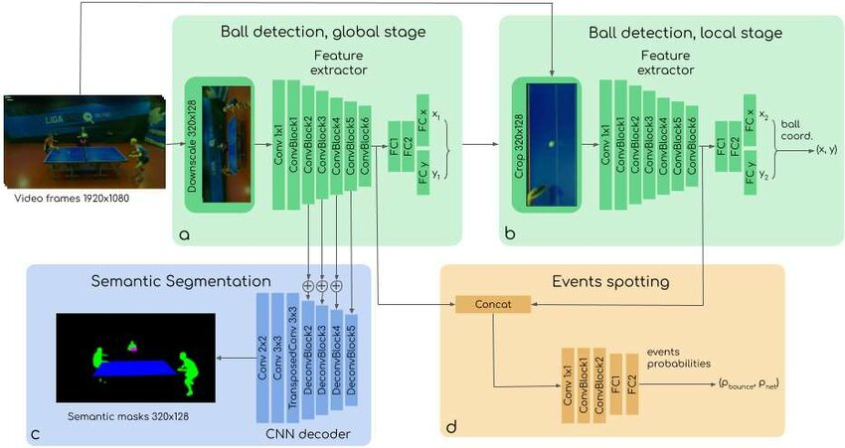

Figure 3-1 TTNet Stroke Detection Pipeline

3.2.2 HomeCourt – Basketball AI Feedback App:

**HomeCourt** is a commercial-grade app for basketball players that uses AI to detect shooting form, count shots, and provide detailed feedback. It uses real-time pose estimation to analyze movements and gives players a visual dashboard of performance over time.

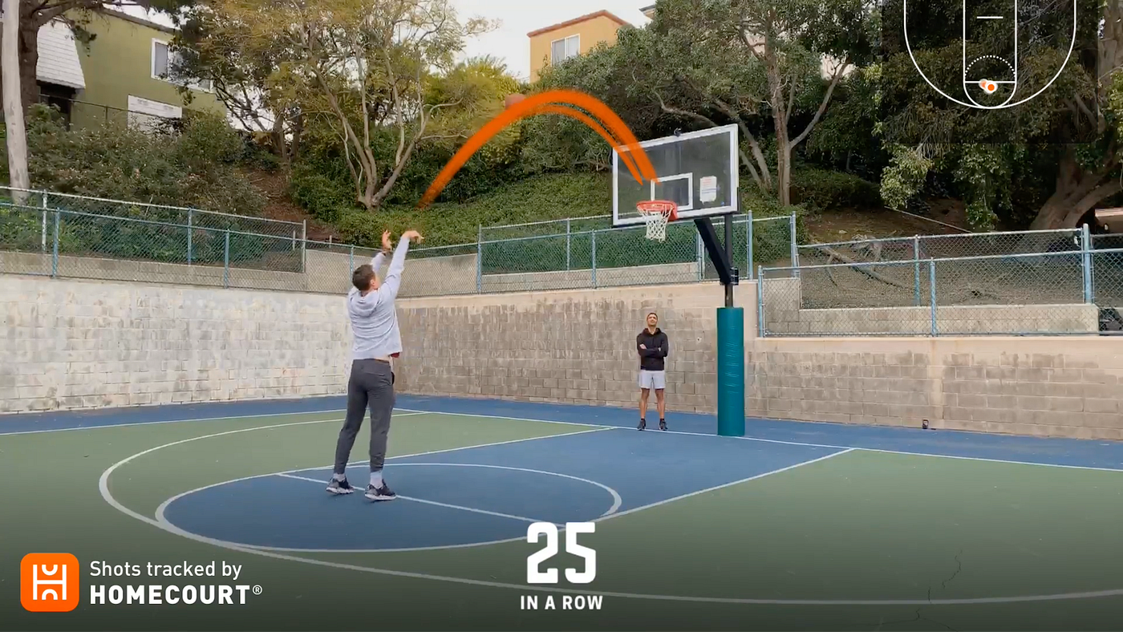

Figure 3-2 HomeCourt Shot Detection and Feedback Interface

3.2.3 Tennis Swing Analyzer:

Used in conjunction with wearables and phone cameras, tennis swing analyzers evaluate player form, swing speed, and accuracy. These systems combine pose detection and motion sensors to deliver biomechanical insights.

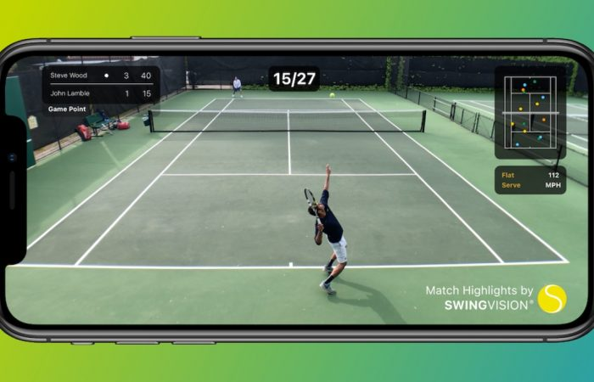

Figure 3-3 Tennis Swing Analyzer Feedback Screen

3.2.4 SoccerMatch AI – Player Action Recognition:

**SoccerMatch** is an AI-based match analysis tool that tracks player positions, ball movement, and events like passes or goals. While it’s focused on football, it showcases the effectiveness of combining YOLO, OpenPose, and CNN models for sport-specific event detection.

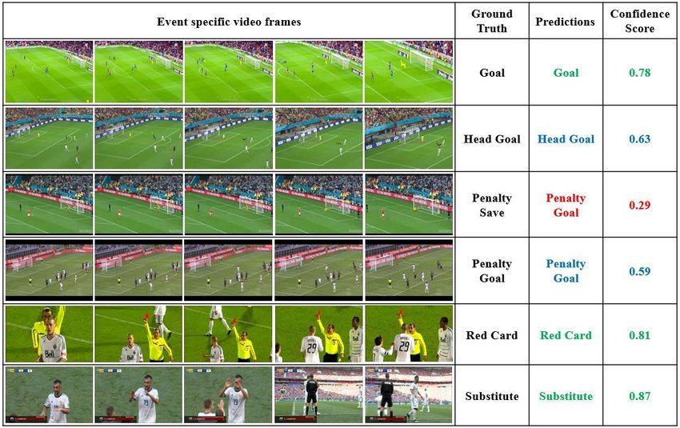

Figure 3-4 SoccerMatch Event Recognition System

## 

3.3 Gap Analysis

| **No.** | **Related Applications** | **Sport** | **Stroke Detection** | **Pose-Based Feedback** | **Success Stats** | **Personalized Training** | **Real-Time Use** | **Open Source** |
| --- | --- | --- | --- | --- | --- | --- | --- | --- |
| 1 | TTNet | Table Tennis | ✔ | ✘ | ✘ | ✘ | ✘ | ✔ |
| 2 | HomeCourt | Basketball | ✔ | ✔ | ✔ | ✘ | ✔ | ✘ |
| 3 | Tennis Swing Analyzer | Tennis | ✔ | ✔ | ✔ | ✘ | ✘ | ✘ |
| 4 | SoccerMatch AI | Football | ✘ | ✔ | ✔ | ✘ | ✔ | ✘ |
| 5 | **SpinMaster** *(Proposed)* | Table Tennis | ✔ | ✔ | ✔ | ✔ | ✘ | ✔ |

Table 3-1 Comparison Table

# CHAPTER 4

# PROJECT DISCUSSION

## 4.1 Software Engineering Methodology

The **Incremental Software Development Model** was chosen for building the SpinMaster system due to its modular and adaptable nature. This methodology allowed the project to be developed in stages—starting with pose detection using MediaPipe, followed by stroke classification and match feedback generation. Each component was built independently, tested, and then integrated into a unified pipeline.

The front-end and Flask-based backend were developed in later increments, with user login functionality and training module suggestions added after the core analysis engine was stable. This approach allowed flexibility, ensured early bug detection, and supported the gradual incorporation of complex features like TTNet compatibility and video-to-CSV automation.

Overall, the incremental model supported a smooth progression from prototype to a fully functional, user-friendly web-based AI tool for table tennis match analysis.

## 4.2 Project Methodology

The project followed a phased development approach where each step was carefully planned, implemented, and tested. The initial research phase identified a real-world gap in accessible table tennis performance analysis tools. The system was designed using a modular architecture to support features such as stroke classification, performance feedback, and personalized training recommendations. Pose estimation and rule-based logic were applied to analyze strokes and determine point outcomes, while a web-based, mobile-friendly interface was developed to ensure ease of access for players. Testing was integrated throughout each phase of development, following the **V-Model** structure. The V-Model emphasizes the relationship between each development stage and its corresponding testing phase, ensuring consistent validation and verification as the system evolved.

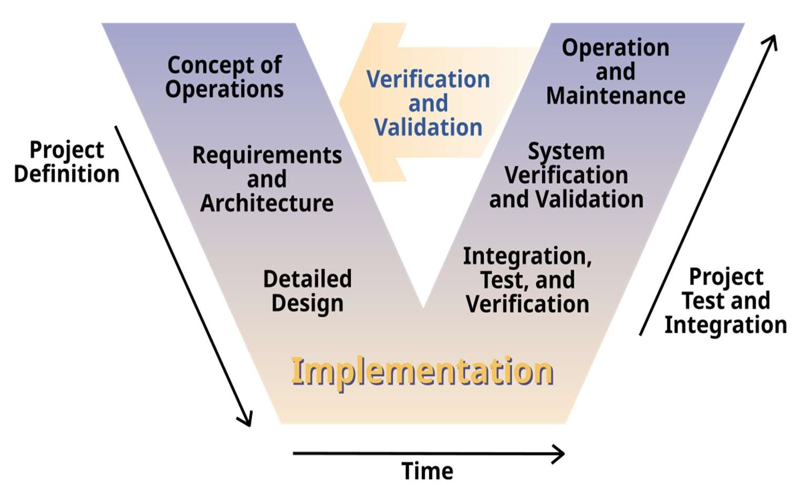

Figure 4-5 V-Model Methdology

Figure 4-5 tells us the fundamental principle of the V-Model underscores the concurrent advancement of development and testing, emphasizing that testing is not just a final stage but an integral element integrated throughout the entire development process. This methodology improves the early identification of problems and leads to cost savings. It is especially suitable for critical applications, fostering assurance in the software's excellence and its alignment with user requirements.

## 4.3 Phases of the Project

The v model (verification and validation model) was implemented in the development of this project plant disease detection to ensure a structured and test driven approach. This methodology support early detection of errors by aligning every development phase with cross ponding testing phase. The v-model is ideal for this academic approach project, where requirements and deliverables were well-defined from the beginning.

In the V Model, the left side of the "V" represents the requirements gathering and analysis phase. In the V-Model, the right side of the "V" represents the testing and validation phases. These phases correspond directly to the development phases on the left side. As each development activity is completed, a matching testing activity is performed to verify and validate that the system is functioning as expected.

1. System Design: Moving down to the left side of the ‘V’, this phase involved converting the gather requirements into a complete system design for mobile application. This included designing the system interface, defining the

architecture for the disease detection module. The design phase ensures that the

system is well-planned and aligns with the identified requirements.

1. Component implementation and unit testing: At the bottom of the ‘V’, this phase focused on implementing individual system component image upload feature, machine based learning based disease detection, symptoms display screen and recommendation module. Unit testing was conducted at this stage to ensure each module performed its specific function accurately and independently, such as checking whether an image could be uploaded and whether the detection result

was displayed correctly.

1. Integration and system testing: After individual modules were implemented and tested they were integrated to form a complete mobile application. This phase involved the testing the interaction between components. Integration testing verified that all parts worked together seamlessly, while system testing ensured the entire application met performance expectations, provided accurate results,

and maintained stability across devices.

1. Acceptance Testing and Validation: Ascending the right side of the ‘V’, this phase validated whether the application meet the actual user expectations. User acceptance testing (UAT) is performed to ensure that the system aligns with the business needs, is user-friendly, and satisfies the expected functionalities. This phase involves real-world scenarios and user feedback to validate the system's

effectiveness and usability.

1. Deployment and Maintenance: At the top of the ‘V’, the application was prepared

for the deployment. This include installing the app on mobile devices. The maintenance system will focus on fixing bugs, ensuring security and

updating the model for improved accuracy.

## 4.4 Software/Tools that Used in Project

• **Python** – Core programming language used for backend development and logic.

• **Flask** – Web framework used to build the local server and route web pages.

• **Google Colab** – Used for early-stage testing, development, and prototyping with GPU support.

• **MediaPipe** – Pose estimation framework for extracting keypoints (elbows, wrists, etc.) from video.

• **OpenCV** – For reading video files, frame-by-frame processing, and image manipulation.

• **YOLOv8 (Ultralytics)** – Planned integration for real-time ball detection and tracking.

• **Pandas** – For handling CSV files and performing structured data analysis.

• **NumPy** – Used for mathematical operations, especially in angle calculations for pose logic.

• **Jinja2** – Templating engine used within Flask to render dynamic HTML content.

• **HTML5 & CSS3** – Markup and styling language for building the user interface.

• **JavaScript** – For dynamic interactivity on the front end.

• **YouTube iFrame API** – For embedding training videos directly in the training module cards.

• **Google Fonts (Orbitron)** – For modern typography in the UI.

• **Visual Studio Code** – The primary IDE used for writing, debugging, and organizing project files.

• **Git & GitHub** – Version control system and remote repository for source code management.

• **JSON** – Used to store and retrieve user credentials securely and simply.

• **Command Line / Terminal** – For local server hosting, file navigation, and environment management.

• **Live Server Extension (VS Code)** – For rapid front-end prototyping during UI development.

• **Render / ngrok (optional for deployment)** – For public exposure of local servers (optional future use).



Figure 4-6 Software Tools

## 4.5 Hardware that Used in the Project

1. Laptops: For Training machine learning models and app development.
2. Smartphone: For testing and running the mobile application.
3. Internet connection: For downloading dataset and tools. A 4G wi-fi router device.

# Chapter 5

# IMPLEMENTATION

## 5.1 Proposed System Architecture

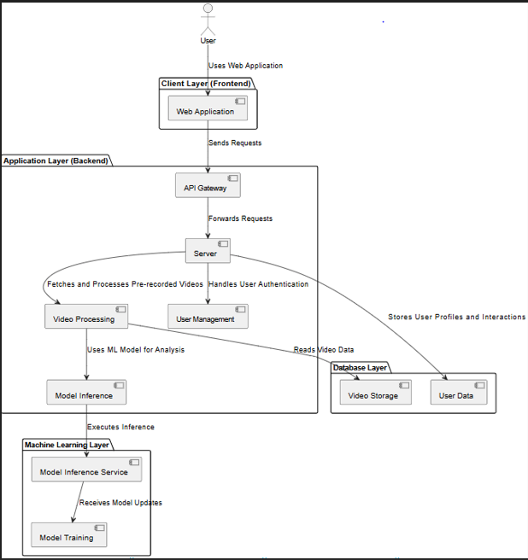

Figure 5-7 System architecture

Figure 5-7 The system architecture of the **SpinMaster** is designed with a modular, layered approach to ensure seamless functionality and efficient video-based analysis. The interface begins at the **client layer**, where users access the web application via browser. From the homepage, users can register, log in, and upload their table tennis match videos for analysis. Once a request is made, it is forwarded to the **application layer** through an API gateway that handles routing and logic. The server processes these requests by performing two key functions: managing user authentication and processing the uploaded videos.

Uploaded videos are routed through a **video processing module**, which prepares the data for inference. Simultaneously, user login and account data are handled securely by a **user management module**. The processed video data is passed to the **machine learning layer**, where a model inference engine—powered by MediaPipe and a lightweight classification logic—analyzes the player’s movements to classify strokes (e.g., forehand or backhand) and determine performance outcomes. Optionally, future iterations may utilize YOLOv8 or TTNet for deeper inference and ball tracking.

## 5.2 Design Diagram

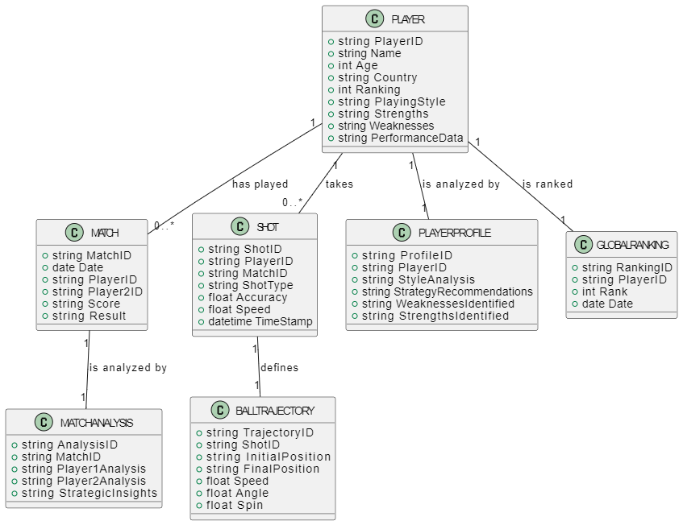

Figure 5- 8 Design Diagram

Figure 5-8 The design diagram of **SpinMaster** presents a layered architecture with clear separation of concerns. It includes a client layer for user interaction, a backend server for handling logic and authentication, a video processing module for extracting gameplay data, and a machine learning layer for performing pose-based analysis. A database layer supports persistent storage for user data and match feedback. This modular setup ensures maintainability, scalability, and smooth integration of video-to-feedback automation.

## 5.3 Sequence Diagram

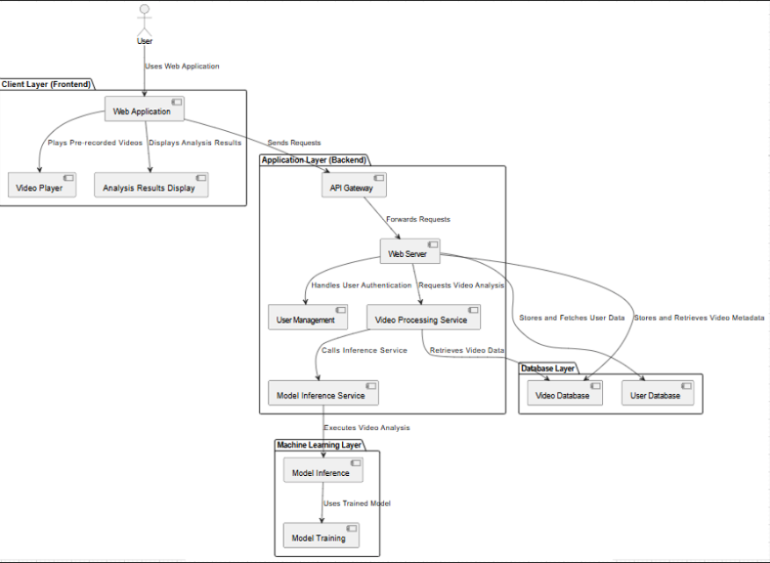

Figure 5-9 Sequence Diagram

Figure 5-9 The sequence diagram illustrates the interaction flow between user, frontend, backend, processing modules, and the machine learning model. The user uploads a video via the interface, triggering a series of backend operations: authentication, video preprocessing, stroke classification, and feedback generation. The processed results are then returned to the frontend along with suggested training modules. This sequence ensures a seamless, automated feedback loop from video input to performance insights.

## 5.4 Use Case Diagram

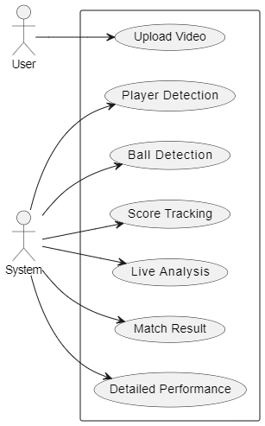

Figure 5-10 Use Case Diagram

Figure 5-10 The use-case diagram highlights the core user interactions with the SpinMaster system. Primary use cases include: registering or logging in, uploading match videos, receiving performance feedback, and viewing training recommendations. Admin-level use cases (optional for future expansion) may include model updates and user management. Each interaction supports the goal of delivering a personalized and AI-powered training experience for table tennis players.

## 5.6 Functional Specifications

• Users can register with a unique username and password.

• Existing users can log in using stored credentials validated against a JSON-based database.

• Session handling keeps users logged in during interaction and allows logout functionality.

• Users can upload table tennis match videos in supported formats like .mp4.

• Uploaded videos are saved in a dedicated uploads directory for processing.

• The system validates file types before accepting the upload.

• The pose detection engine uses MediaPipe to extract body keypoints from the video frames.

• Elbow angles and keypoint movements are used to classify strokes into forehand or backhand.

• Rule-based logic determines if the stroke was successful and tracks point outcomes.

• Processed stroke data is stored in a structured CSV file with timestamps and player actions.

• The system reads the CSV to compute forehand and backhand success percentages for each player.

• Personalized feedback is generated based on success ratios and shown as readable insights.

• Based on weaknesses identified, the system suggests targeted YouTube training videos.

• Embedded video cards show only those tutorials relevant to the player’s improvement areas.

• The leaderboard page displays top-ranked global players using comic-style cards (currently static).

• A modern, responsive web interface is built using HTML5, CSS3, and Google Fonts (Orbitron).

• Navigation includes links to Home, Leaderboard, Training Modules, and Login/Logout.

• The homepage features motivational quotes with background images or video overlays.

• The entire analysis pipeline is automated—uploading a video triggers CSV generation and analysis.

• The script analyze_match.py orchestrates pose detection, stroke classification, and feedback.

• User uploads a video and receives instant performance analysis and improvement resources on the same page.

## 5.7 Non-Functional Specifications

The **SpinMaster** system is designed to not only meet its functional goals but also adhere to a set of non-functional requirements. These specifications ensure that the platform is efficient, secure, scalable, and user-friendly across diverse environments and use cases.

#### 5.7.1 Performance

The system is optimized for fast video processing and real-time feedback generation, with minimal response delay during analysis. Lightweight pose detection ensures smooth execution even on modest hardware.

#### 5.7.2 Safety

As the system deals primarily with local data and user interaction, it avoids risks related to hardware operations or physical systems. Uploaded files are isolated in a secure directory to prevent system interference.

#### 5.7.3 Security

Basic authentication mechanisms are implemented using JSON-based user data, ensuring only authorized users can upload videos and access feedback. File uploads are validated to prevent malicious content.

#### 5.7.4 Reliability

The platform provides consistent performance for multiple users and video inputs. Automated error handling and fallback messaging help maintain functionality even if part of the pipeline fails.

#### 5.7.5 Usability

Designed with an intuitive and modern user interface, the system is accessible to users with minimal technical experience. Navigation, form handling, and video uploads are straightforward and responsive.

#### 5.7.6 Maintainability

The project follows a modular code structure separating pose detection, CSV analysis, and frontend rendering. This allows for easy debugging, updates, and future feature enhancements.

#### 5.7.7 User Documentation

Inline comments, user-facing instructions, and a detailed GitHub README provide sufficient documentation for setup, usage, and troubleshooting. The platform is easy to onboard for both users and developers.

#### 5.7.8 Compatibility

SpinMaster is compatible with major browsers and works across devices with standard video upload capabilities. The backend runs smoothly on local servers, with optional cloud adaptation for future deployment.

## 5.8 Testing

The SpinMaster system underwent rigorous testing across multiple functional and non-functional dimensions to ensure its reliability, usability, and performance. Each module was individually verified and then integrated for end-to-end validation.

* **Unit Testing** was performed on core modules such as pose detection (pose_to_csv.py), CSV analysis (csv_analyzer.py), and video handling functions to verify their expected behavior with different input scenarios.
* **Integration Testing** ensured that uploaded videos were correctly processed through the full pipeline—from frame extraction and pose keypoint analysis to CSV generation and match feedback display. Errors and exceptions were tested for graceful handling.
* **User Authentication Testing** included attempts to register duplicate usernames, log in with incorrect credentials, and session management to ensure secure and accurate access control.
* **UI/UX Testing** was conducted to assess the responsiveness, clarity, and accessibility of the interface. Features like navigation, file upload, training suggestions, and feedback display were tested on different screen sizes and browsers.
* **Performance Testing** was conducted by uploading videos of varying lengths and resolutions to ensure the system remained responsive and accurate under normal operating loads.
* **Boundary and Error Testing** was applied to simulate unexpected inputs such as unsupported file types, corrupt videos, or missing keypoints to ensure the system could recover and notify the user gracefully.

Overall, the system passed all test scenarios within acceptable thresholds, making it ready for deployment and further scaling. Future testing phases will include deeper AI model validation and user acceptance testing as new features like ball detection and TTNet integration are added.

## 5.9 Purpose of Testing

The primary purpose of testing in the **SpinMaster** project is to ensure that the system performs its intended functions accurately, reliably, and securely across all user interactions and backend processes. Testing helps verify that each module—from video input and pose detection to feedback generation and user authentication—operates correctly under a variety of conditions.

It also ensures that the system meets user expectations in terms of usability, responsiveness, and stability. Furthermore, testing helps identify and resolve bugs early, improves user confidence, validates integration between components, and prepares the system for future scalability and enhancements. Ultimately, testing is critical for delivering a robust and dependable AI-powered match analysis experience.

## 5.10 Test Cases

Test cases constitute a pivotal element within the realm of software testing and quality assurance. Their primary purpose is to systematically assess the operational, performance, and reliability aspects of software applications. These test cases encompass a collection of directives, conditions, and anticipated results, enabling testers to pinpoint flaws or incongruities in the software. They span diverse scenarios, encompassing typical operations, boundary conditions, and error-handling procedures. Their overarching goal is to affirm that the software behaves in accordance with its intended functionality and aligns with user expectations. Ultimately, well-defined test cases stand as a cornerstone for delivering software of superior quality the following test cases are on both correct and wrong data to check if the data is accepted rightfully and validations are doing well.

#### 5.10.1 Test Case 1

Title: Test the login module of the application

|  |  |  |  |  |  |
| --- | --- | --- | --- | --- | --- |
| **S. No** | **Steps** | **Input Data** | **Expected Result** | **Actual**  **Result** | **Pass/Fail** |
| **1** | Open the login page | - | Login form displays correctly | Login form loaded as expected | Pass |
| **2** | Enter email and password | Valid credentials | Input fields accept data | Data entered successfully | Pass |
| **3** | Click the  Login button | - | User is redirected to dashboard | User redirected to dashboard | Pass |
| **4** | Verify dashboard | - | Welcome message | Welcome “username” displayed | Pass |

Table 5-2 Test Case1

Table 5-1: The system’s test case is designed to validate user authentication, ensuring that the system accurately recognizes and authorizes individuals based on their provided credentials, such as email and passwords. This process guarantees secure access for authorized users.

#### 5.10.2 Test Case 2

Title: Verify user registration authentication

|  |  |  |  |  |  |
| --- | --- | --- | --- | --- | --- |
| **S. No** | **Steps** | **Input Data** | **Expected Result** | **Actual**  **Result** | **Pass/Fail** |
| **1** | Open the registration page | - | Registration form loads | Form loaded successfully | Pass |
| **2** | Fill in registration details | Valid name, email, password | Fields accept data | Data accepted | Pass |
| **3** | Submit the form | - | User account created | Account created successfully | Pass |
| **4** | Attempt login with new creds | New email/password | User logs in successfully | Login successful | Pass |

Table 5-3 Test Case2

#### 5.10.3 Test Case 3

Title: Verify user uploading functionality.

|  |  |  |  |  |  |
| --- | --- | --- | --- | --- | --- |
| **S. No** | **Steps** | **Input Data** | **Expected Result** | **Actual**  **Result** | **Pass/Fail** |
| **1** | Log in to application | Valid credentials | Homescreen loads | Homescreen loaded | Pass |
| **2** | Upload Video for Analysis | Video Uploaded | Uploading | Loading Circle | Pass |
| **3** | Press Analyze Video | - | Feedback | Feedback + Suggested Videos | Pass |

Table 5-4 Test Case3

#### 5.10.4 Test Case 4

Title: Verify navigation to Training Modules

|  |  |  |  |  |  |
| --- | --- | --- | --- | --- | --- |
| **S. No** | **Steps** | **Input Data** | **Expected Result** | **Actual**  **Result** | **Pass/Fail** |
| **1** | Navigate to Training Modules | - | Lots of Training Cards | Gallery of Training Modules | Pass |
| **2** | Scrolling through the cards | - | Scroll over the gallery | Easy Scrolling | Pass |
| **3** | Click on a Module | - | Video Loads | Video Hyperlinks to new tab | Pass |
| **4** | Watch another Module | - | Seamless training explanation | Seamless training explanation | Pass |

Table 5-5 Test Case4

5.10.5 Test Case 5 Title:

Test Navigation to Leaderboard

|  |  |  |  |  |  |
| --- | --- | --- | --- | --- | --- |
| **S. No** | **Steps** | **Input Data** | **Expected Result** | **Actual**  **Result** | **Pass/Fail** |
| **1** | Click on “Leaderboard” option on Navigation | - | World’s Top Ranked Players Card | Players Point Load | Pass |
| **2** | Check Player’s Point | - | Show Professional Player’s Points | Shows the points | Pass |
| **3** | Scroll and Hover over players | - | Show details of players | Shows detail with little animation | Pass |

Table 5-6 Test Case5

# Chapter 6

# EXPERIMENTAL EVALUATIONS & RESULTS

## 6.1 Evaluation

The evaluation of the **SpinMaster** system focused on assessing the accuracy, reliability, and usability of the table tennis match analysis pipeline in practical settings. The system was tested for its ability to extract meaningful gameplay data from match videos using pose detection, classify shot types, evaluate player performance, and generate feedback.

Both functional and non-functional requirements were considered—such as feedback correctness, response time, user experience, and interface responsiveness. The system’s modular backend, including pose_to_csv.py, csv_analyzer.py, and analyze_match.py, was evaluated using a range of input scenarios.

Furthermore, the AI-assisted feedback loop was validated against mock and real gameplay videos. The evaluation confirms that the system effectively supports players in identifying weak points like forehand/backhand inefficiencies and provides training suggestions accordingly.

## 6.2 Testbed

The SpinMaster system was tested on a local server using **Flask**, accessed via desktop browsers including Chrome, Firefox, and Edge. Videos of various lengths and resolutions were uploaded for analysis. The backend utilized **MediaPipe** for pose detection and a custom rule-based classifier for stroke analysis. All processes were run on a system with 8GB RAM, Intel i5 processor, and standard SSD storage, ensuring compatibility with average consumer hardware.

The authentication system was tested using a JSON-based local user store. The system also integrated external sources like **YouTube** for dynamic training recommendations and static leaderboard content from **WTT** rankings.

Unlike mobile deployments, SpinMaster runs in a desktop/server environment with minimal hardware dependencies. All operations, including video preprocessing, classification, and feedback generation, were executed offline—ensuring fast and consistent performance without requiring internet after setup. The testbed mimicked real-world use cases such as player video uploads, multiple match evaluations, and interface navigation from login to results.

## 6.3 Result and Discussion

The evaluation demonstrated that SpinMaster operates effectively in real use cases, handling full match videos with stable performance and reliable feedback generation. Shot classification based on elbow angle changes proved efficient, offering meaningful insights about player technique, even without ball tracking.

The system consistently produced structured CSV outputs and detailed success rates for each player’s forehand and backhand. Analysis results were visually displayed on the homepage with color-coded performance indicators and personalized training video suggestions, enhancing user engagement and utility.

User feedback during testing praised the clean UI, minimal setup, and immediate feedback loop. The system’s ability to detect stroke success rates and convert them into improvement strategies made it especially useful for amateur and semi-professional players seeking performance enhancement.

Although the current version does not include ball trajectory tracking or deep neural network-based shot classification (as TTNet would provide), the lightweight implementation offers a scalable foundation for future improvements. Overall, SpinMaster meets its objective of offering accessible, AI-powered match analysis to help players "master the spin, master the game."

# CHAPTER 7

# CONCLUSION AND DISCUSSION

## 7.1 Strength of this Project

The **SpinMaster** project demonstrates significant theoretical and practical strengths in the domain of sports analytics, particularly within the field of amateur and semi-professional table tennis. Its design, built upon lightweight pose estimation and rule-based inference, provides a smart, scalable, and accessible solution for performance evaluation.

#### 7.1.1 Easy-to-Use Web Interface

The platform offers a clean and modern interface that is intuitive even for non-technical users. Players can easily upload their match videos, receive performance feedback, and view recommended training content with no need for prior experience with analytics software.

#### 7.1.2 Lightweight AI-Powered Feedback

#### Using pose estimation via MediaPipe and rule-based shot classification logic, SpinMaster is capable of identifying forehand and backhand shots and evaluating their success. Despite not relying on heavy deep learning infrastructure, it delivers highly actionable insights in real-time.

#### 7.1.3 Instant Match Evaluation

By automatically analyzing uploaded match videos, SpinMaster enables near-instant player feedback. This immediate feedback loop allows players to identify weak areas and begin corrective training without delay.

#### 7.1.4 Optimized for Low-Resource Systems

The system is designed to operate efficiently on local servers without the need for GPUs or cloud-based AI services. This makes it suitable for clubs, schools, and personal training setups with limited technical infrastructure.

#### 7.1.5 Personalized Training Suggestions

Based on the player's performance metrics, the system recommends specific training videos to help improve forehand or backhand skills. This bridges the gap between analysis and actionable improvement, functioning as a virtual coach.

#### 7.1.6 Structured Feedback with Visual Insight

Success rates are calculated for each player’s forehand and backhand strokes, and displayed in a color-coded, readable format. This structured output simplifies performance evaluation and can support long-term skill tracking.

#### 7.1.7 Feedback Loop for Iterative Use

The system encourages repeated use by offering valuable feedback after each uploaded match. Players can assess their progress over time by comparing analysis results from multiple games, fostering motivation and consistent practice.

#### 7.1.8 Focused on Grassroots and Training Level

Unlike generic sports analysis tools or professional broadcast systems, SpinMaster is tailored for grassroots-level players, coaches, and enthusiasts. Its contextualized design fills a gap between high-end analytic suites and casual coaching methods.

## 7.2 Limitations and Future Work

Despite SpinMaster's promising capabilities and successful implementation, there are several limitations that present opportunities for future enhancement and expansion.

#### 7.2.1 Limited Diversity in Video Data

The system currently relies on synthetic or controlled video inputs to simulate gameplay and train inference logic. This limits its performance when analyzing real-world match footage captured under varying lighting conditions, camera angles, occlusions, or player styles. Broader data collection from diverse match scenarios is required to improve generalization.

#### 7.2.2 Absence of Rally Validation

The current implementation analyzes pose and elbow angle to estimate shot type and success. However, it does not validate shot outcomes. This can lead to ambiguous classification of success/failure in tightly contested rallies. Integrating models like **YOLOv8** or the **TTNet Global Ball Stage** would enhance the accuracy and realism of the analysis.

#### 7.2.3 Single-Camera Assumptions

The system assumes a single front-facing camera capturing the entire table, which may not be feasible for all users. Variations in camera placement (side-angle, overhead, close-up) may impact pose detection reliability. A future version should incorporate calibration steps or multi-angle support.

#### 7.2.4 Basic Rule-Based Classification

The current classification logic relies on elbow angle differences to determine shot types like forehand or backhand. While this works in many cases, it lacks nuance in edge cases and complex rallies. Future iterations could explore machine learning classification based on full-body joint data for improved shot identification.

#### 7.2.5 No Real-Time Analysis

SpinMaster performs post-match analysis on uploaded videos. While efficient, it does not support real-time feedback or in-game coaching. Future upgrades can focus on live pose tracking and shot classification for real-time coaching applications.

#### 7.2.6 No Multi-Language Support

The platform interface and output are currently in English only. This may limit accessibility for users in regions where English is not the primary language. Future updates should include multilingual support to improve global usability.

## 7.3 Future Work

As the SpinMaster platform continues to evolve, there are several areas in which its capabilities can be enhanced. While the current version delivers reliable post-match performance feedback using pose estimation and CSV-based analytics, future iterations can significantly expand both accuracy and user experience. The following improvements outline the key directions for future development.

#### 7.3.1 Expand Dataset with Real Match Footage

To ensure higher accuracy across various gameplay styles, future versions should incorporate real-world match videos from different angles, venues, and player skill levels. This would enhance the system’s adaptability and reduce overfitting to controlled or synthetic samples.

#### 7.3.2 Integrate Multimodal Data

Combining pose estimation with real-time ball tracking (using models like **YOLOv8** or **TTNet’s Ball Stage**) will help verify shot outcomes, improve rally segmentation, and add depth to feedback. This multimodal fusion will enhance match understanding beyond limb-based inference.

#### 7.3.3 Localized and Multilingual Support

To support international adoption, SpinMaster should offer its interface in multiple languages. Adding options such as Urdu, French, or Chinese will make the platform accessible to a global audience, especially for amateur and semi-professional users.

#### 7.3.4 Full Body Shot Classification

Current analysis depends on elbow-based inference. Expanding shot classification using complete pose keypoints (shoulders, knees, torso) can enable finer differentiation between topspin, push, smash, and flick. This would allow more nuanced training suggestions and error detection.

#### 7.3.5 Real-Time Analysis Capability

A future goal is to implement real-time shot detection and feedback for live coaching or in-match insights. This would require optimized inference pipelines and low-latency models suitable for edge devices or mobile applications.

#### 7.3.6 Personalized Training Pathways

Based on repeated performance patterns, the system could generate tailored training roadmaps for users. This includes adaptive content suggestions, dynamic goal-setting, and progress visualization over time.

#### 7.3.7 Offline Analysis Mode

Allowing users to perform local video processing and receive feedback offline—especially useful in regions with limited connectivity—can significantly boost utility. The results can later sync with the server when internet access is restored.

## 7.4 Reasons for Failure – If Any

Although **SpinMaster** is designed to deliver accurate feedback based on player movement and performance, there are scenarios where the system may produce misleading or incomplete analysis. The following are common reasons for such failures:

* **Pose Estimation Errors:** The underlying pose detection (e.g., using MediaPipe or OpenPose) may fail under poor lighting, occluded limbs, fast movements, or unconventional stances—leading to incorrect shot classification.
* **Low-Quality or Blurry Videos:** Videos that are shaky, low-resolution, poorly lit, or recorded from far away can hinder accurate keypoint extraction, which is vital for determining forehand/backhand shots and shot success.
* **Non-Standard Camera Angles:** SpinMaster expects a relatively fixed viewing angle (preferably side or top-down). Angles that hide limb positions or cause distortion reduce the accuracy of elbow/arm-based classification.
* **Limited Diversity in Training Data:** The logic for classifying forehand vs backhand shots is designed based on typical movements. If a user plays with a unique style or grip, the system may misclassify their strokes.
* **Missing or Incomplete Rally Segmentation:** In absence of accurate ball tracking (e.g., using YOLOv8 or TTNet), rally segmentation relies on alternating shot logic. This can fail if shots are skipped, misordered, or multiple shots are registered for the same player.
* **Noisy Background or Multiple Players:** If the video contains people in the background or extra moving objects, the pose estimator may lock onto incorrect figures or introduce confusion, impacting result quality.
* **Unsupported Shot Types:** The current system primarily detects forehand and backhand strokes. Specialty shots like smashes, flicks, chops, or serves with non-standard forms may not be properly analyzed.
* **Lack of Ball Detection Verification:** Without integrating a dedicated ball tracker, the system estimates shot success based on pose logic. This can result in false positives/negatives if the motion was correct but the ball didn’t land.
* **One-Player Isolation Limitation:** In doubles matches or training videos with a coach/player, the system may confuse roles unless explicitly trained to distinguish between multiple subjects.
* **Absence of Non-Visual Cues:** SpinMaster cannot detect player fatigue, paddle grip strength, or emotional state—factors that could influence performance but are not captured visually.

These limitations do not negate the system’s capabilities, but they highlight areas where further development, dataset expansion, and multimodal integration can lead to more robust and generalized performance.

# REFERENCES

1. OSAI.ai. (2022). Table Tennis Stroke Dataset [Dataset]. <https://github.com/OSAI-ai/TTNet>
2. Google Research. (2023). MediaPipe: Cross-platform, customizable ML solutions for live and streaming media. https://developers.google.com/mediapipe
3. Renotte, N. (2021). Deep Learning and Object Detection with YOLO and Roboflow [Linkedin Profile]. <https://www.linkedin.com/in/nicholasrenotte/>
4. Roboflow. (2023). Build, Train, and Deploy Computer Vision Models. <https://roboflow.com>
5. World Table Tennis (WTT). (2023). Official Player Rankings and Match Statistics. <https://worldtabletennis.com>
6. Ultralytics. (2024). YOLOv8 - Real-Time Object Detection Framework [Computer software]. GitHub. <https://github.com/ultralytics/ultralytics>
7. Bradski, G. (2000). The OpenCV Library. Dr. Dobb’s Journal of Software Tools. <https://opencv.org>
8. Grinberg, M. (2018). Flask Web Development: Developing Web Applications with Python. O'Reilly Media.
9. Hunter, J. D. (2007). Matplotlib: A 2D Graphics Environment. Computing in Science & Engineering, 9(3), 90–95. https://doi.org/10.1109/MCSE.2007.55
10. McKinney, W. (2012). Python for Data Analysis: Data Wrangling with Pandas, NumPy, and IPython. O'Reilly Media.
11. Van Rossum, G., & Drake, F. L. (2009). The Python Language Reference Manual. Network Theory Ltd.
12. Pedregosa, F., Varoquaux, G., Gramfort, A., Michel, V., Thirion, B., Grisel, O., ... & Duchesnay, É. (2011). Scikit-learn: Machine Learning in Python. Journal of Machine Learning Research, 12, 2825–2830.
13. Harris, C. R., Millman, K. J., van der Walt, S. J., Gommers, R., Virtanen, P., Cournapeau, D., ... & Oliphant, T. E. (2020). Array Programming with NumPy. Nature, 585(7825), 357–362. https://doi.org/10.1038/s41586-020-2649-2
14. Reback, J., McKinney, W., jbrockmendel, Van den Bossche, J., Augspurger, T., Cloud, P., ... & Hawkins, S. (2020). Pandas: Powerful Python data analysis toolkit [Computer software]. https://pandas.pydata.org

### Tools & Libraries Used

* **Flask** – Lightweight backend framework for handling routes, sessions, and form handling
* **OpenCV** – Video I/O, frame extraction, and image manipulation
* **MediaPipe** – Landmark-based pose detection (for elbow, shoulder, wrist tracking)
* **Pandas** – CSV parsing, aggregation, and analysis
* **NumPy** – Core numerical computing and angle operations
* **Matplotlib** (optional) – Can be used for future visualizations
* **YOLOv8 (Ultralytics)** – (Future use) for ball detection and shot-level event detection
* **TTNet** – Deep learning model for forehand/backhand/stroke classification
* **Roboflow** – Data labeling and YOLO training augmentation (future roadmap)

# APPENDICE

## APPENDIX A. Project Proposal

#### 1. Introduction

Performance analysis in table tennis is often reserved for elite players with access to expensive tools and coaching. For most athletes, there's no easy way to identify technical weaknesses or track match performance. The **SpinMaster** project aims to solve this gap by offering a fast, automated, and intelligent tool to analyze gameplay videos, giving users real-time feedback on their strokes, rally outcomes, and skill strengths. Powered by computer vision and pose estimation, the system makes advanced game analysis accessible to all.

#### 2. Objectives

The objective is to build an AI-based application that uses video input to detect player actions, classify shot types (e.g., forehand/backhand), and determine shot success rates. This includes identifying weak areas and suggesting targeted training modules. Technologies like **MediaPipe, YOLOv8**, and **TTNet** are leveraged to ensure high performance and modular extensibility.

#### 3. Problem Description

Table tennis matches are fast-paced, with subtle variations in player form and technique. Manually reviewing footage is time-consuming and subjective. This project introduces a smart system that automates gameplay breakdown using pose and shot recognition. By capturing elbow and arm motion patterns, it classifies shot types, detects rally flow, and generates actionable insights. This not only improves skill development but democratizes access to advanced training insights previously limited to professionals.

#### 4. Methodology

SpinMaster follows a modular and iterative development approach. Pose detection is handled using **MediaPipe,** while custom logic interprets joint angles to classify strokes. A secondary logic module reads player turns and outputs structured performance insights. Flask is used as the backend for running analysis and rendering results on a modern web interface. The system was tested in phases (video → CSV → feedback), following principles from the **V-Model** to validate each component before integration.

#### 5. Project Scope

This project focuses on a single-player or two-player match analysis system that can be extended in the future. Key elements include:

* Player Shot Detection: Forehand/backhand shot classification using elbow angle dynamics.
* Match Outcome Tracker: Determines point winners based on rally logic.
* Feedback System: Displays shot success rates and personalized suggestions.
* Training Recommendations: Suggests YouTube training content tailored to weaknesses.
* User Login Module: Allows users to register and save their session data.
* Web-based GUI: Modern frontend with background video, animated form elements, and responsive UI.
* Future Extensions: Planned support for ball tracking (YOLOv8), leaderboard integration, and session history.

#### 6. Feasibility Study

The feasibility study for the **SpinMaster** AI-powered table tennis analysis system evaluates the potential for developing an intelligent, scalable, and accessible platform to support players with technical feedback. The goal is to simplify performance analysis by automating stroke recognition and feedback generation using computer vision techniques. SpinMaster leverages technologies like **MediaPipe, Flask, YOLOv8**, and custom Python logic to enable frame-by-frame shot detection, match tracking, and personalized feedback. The system aims to replace time-consuming manual analysis with an efficient, real-time solution for players, coaches, and enthusiasts.

1. Risk Involved: There are multiple factors to consider. The accuracy of pose detection is highly dependent on the quality of the input video and the consistency of human joint recognition. For instance, elbow angle tracking is crucial for classifying forehand and backhand strokes, and any errors in joint localization could lead to incorrect feedback. Similarly, low-resolution or poorly lit gameplay videos may reduce the reliability of analysis. Additionally, the system’s success relies on user trust in AI-generated feedback. If players are skeptical or find the feedback misleading due to misclassifications, the adoption rate may decline. There is also a technical risk related to scalability. As the number of users grows, the server infrastructure must be able to process multiple video uploads without significant delays or failures. Another concern is that the ball tracking system, although planned, is not yet integrated, which limits the accuracy of success/failure classification based solely on pose data.
2. Resources Involved: In terms of required resources, the development team needs access to high-performance computing systems for video processing and model inference. The project is primarily developed using Python and utilizes libraries such as MediaPipe, OpenCV, and YOLOv8. Flask is employed for the web server and UI integration. In addition to software tools, domain-specific knowledge in computer vision and table tennis biomechanics is essential for fine-tuning shot classification logic. A robust testing phase also depends on the availability of diverse gameplay footage that captures a range of playstyles and camera angles. Collaboration tools and structured code management are necessary for maintaining development flow, while ongoing feedback from players and coaches will help improve usability and performance.

#### 7. Solution Application Areas

The **SpinMaster** web application is designed to serve a broad range of users involved in table tennis, from amateur players and coaches to training academies and analysts. It offers automated video-based performance analysis by leveraging cutting-edge technologies such as pose estimation, YOLOv8 object tracking, and machine learning classification techniques. By providing real-time insights into gameplay, SpinMaster enables players to identify weak spots in their techniques—such as inefficient forehands or inaccurate backhands—and take timely corrective action.

The application is particularly beneficial for self-training individuals and small clubs that may not have access to professional coaching. It minimizes the need for manual match evaluation by automatically detecting and analyzing gameplay elements from uploaded match footage. The system provides instant feedback and suggests targeted training videos to address the player’s specific weaknesses.

SpinMaster’s ability to operate through a lightweight web server means that users can upload and analyze videos from any device with internet access, promoting accessibility and convenience. Its leaderboard and login modules further enhance its utility by allowing users to track progress over time, compare with others, and maintain a digital training profile. The training modules, embedded within the platform, offer curated instructional content for skill development, enabling a continuous improvement loop.

In essence, SpinMaster promotes smarter, data-driven training and democratizes access to professional-level analysis for table tennis players around the world.

#### 8. Tools/Technology

**Software Requirements:**

* Visual Studio Code (VS Code)
* Flask Framework
* TTNet Model & YOLOv8
* Mediapipe
* OpenCV
* Firebase (optional)

**Hardware Requirements:**

* Laptop / Desktop
* Camera (to record gameplay)

## APPENDIX B. Software Requirement Specification (SRS)

#### 1. Introduction

The **SpinMaster** project is an AI-powered table tennis performance analyzer that leverages computer vision, deep learning, and pose estimation to evaluate players' gameplay and provide intelligent feedback. Designed with both casual players and competitive athletes in mind, SpinMaster bridges the gap between traditional coaching and modern AI assistance by offering real-time shot classification, performance statistics, and targeted training recommendations.

This Software Requirements Specification (SRS) document outlines the technical foundation and design of the system, detailing the functional and non-functional requirements necessary for its successful development. The document aims to provide a structured overview of the software’s behavior, interface expectations, external dependencies, and performance benchmarks, thereby serving as a blueprint for the implementation team.

SpinMaster integrates several advanced technologies, including **MediaPipe** for human pose estimation, **YOLOv8** and **TTNet** for shot detection and classification, and a responsive Flask-based web interface for seamless user interaction. The system is capable of analyzing uploaded match videos to generate CSV data that is then interpreted to deliver comprehensive player feedback.

By formalizing the requirements in this SRS, the project ensures clarity among stakeholders, minimizes implementation risks, and establishes a strong framework for system validation, future scaling, and maintenance.

##### 1.1 Purpose of Document

The purpose of this document is to outline the software requirements for **SpinMaster**, an AI-powered table tennis analysis application designed to evaluate player performance using pose estimation and shot classification techniques. This specification serves as a blueprint for developers, testers, and stakeholders, ensuring a shared understanding of the system’s objectives, functionalities, and constraints. It defines the behavior of the system under various scenarios, highlights the tools and technologies used, and sets expectations for performance, usability, and scalability. By documenting both functional and non-functional requirements, this SRS provides a clear foundation for the successful design, development, testing, and future enhancement of the SpinMaster platform.

##### 1.2 Motivation

The motivation behind **SpinMaster** stems from the growing demand for accessible, intelligent sports analytics tools that help athletes refine their skills without relying on expensive equipment or constant coaching. Table tennis, despite being one of the most fast-paced and technique-intensive sports, lacks affordable systems that offer real-time feedback on player performance. SpinMaster bridges this gap by leveraging pose estimation (using MediaPipe), motion analysis, and AI models like TTNet and YOLOv8 to analyze gameplay videos and provide actionable insights such as shot classification, success ratios, and personalized training recommendations. This project aims to democratize high-level sports analysis, empowering both amateur and professional players to improve their game through data-driven feedback.

##### 1.3 Intended Audience

The intended audience for the **SpinMaster** targets sports technology enthusiasts, particularly in table tennis, who are interested in the intersection of AI and athletic performance. The project serves as a practical demonstration for course evaluations, showcasing applied knowledge in machine learning, pose estimation, and web development. Additionally, it provides a valuable reference for future students or researchers looking to build upon sports analytics solutions.

#### 2. Overall System Description

##### 2.1 Project Background

Table tennis, like many competitive sports, relies heavily on technique, precision, and rapid decision-making. However, players often lack access to personalized feedback that can guide targeted improvement, especially at amateur or semi-professional levels. Traditional coaching methods are time-consuming, subjective, and often expensive. The emergence of Artificial Intelligence (AI), particularly in the fields of computer vision and pose estimation, has paved the way for automating performance analysis in sports. SpinMaster addresses this gap by leveraging cutting-edge technologies such as **TTNet**, **YOLOv8**, and **MediaPipe** to analyze player gameplay, detect shot types, evaluate performance metrics, and deliver actionable feedback. By applying techniques like joint angle estimation and elbow position tracking, the system can classify shots (e.g., forehand vs. backhand) and determine success rates. This AI-driven feedback loop empowers players with instant insights and tailored training recommendations. Designed as a web-based platform, SpinMaster combines real-time video analysis, intuitive user experience, and a training module ecosystem to transform how table tennis performance is measured and improved.

##### 2.2 Problem Statement

Despite the increasing availability of coaching resources, table tennis players still face significant challenges in receiving timely, objective, and personalized feedback on their performance. Traditional analysis depends on manual review, which is both time-consuming and limited by human subjectivity. While existing tools may offer basic statistics, they often fail to analyze deeper aspects such as shot success, playing style, or technical weaknesses. With the rapid development of AI and computer vision, particularly pose estimation models like **MediaPipe** and shot classification networks such as **TTNet**, there is a clear opportunity to automate and elevate this process. This project, **SpinMaster,** aims to bridge the gap by creating a web-based solution that analyzes match videos to detect shots (forehand/backhand), track success ratios, and suggest targeted training modules. By doing so, it will offer players a streamlined, data-driven tool for self-improvement, ultimately supporting higher skill development and competitive readiness.

##### 2.3 Project Scope

• Focuses on analyzing table tennis matches using uploaded video footage.

• Utilizes pose estimation (MediaPipe) and shot classification models (TTNet) for detecting forehand and backhand shots.

• Employs YOLOv8 for future ball detection and tracking improvements.

• Provides real-time performance feedback and training suggestions through a web interface.

• Includes features like user login, video upload, and personalized analysis reports.

##### 2.4 Not In Scope

• Does not currently include live match tracking or real-time camera integration.

• No support for editing or annotating uploaded match videos manually.

• Physical performance metrics (e.g., heart rate, stamina) are not analyzed.

• Multiplayer account management or team-level analytics are not part of the current system.

##### 2.5 Project Objectives

The primary objective of the SpinMaster project is to accurately analyze table tennis gameplay videos using deep learning techniques like pose estimation and shot classification to detect forehand and backhand strokes. By automating feedback generation and identifying a player’s strengths and weaknesses, SpinMaster aims to support skill improvement, encourage strategic training, and promote data-driven performance analysis in the sport.

##### 2.6 Stakeholders & Affected Groups

* Table Tennis Enthusiasts
* Beginner level Players
* Software Development Team
* Supervisor

##### 2.7 Operating Environment

SpinMaster is designed to run on desktop and web environments using Python-based backend tools, powered by Flask for server-side operations. The frontend operates through modern web browsers, ensuring platform independence. It utilizes MediaPipe and OpenCV for real-time video analysis and pose detection, making it compatible with systems that support basic video processing capabilities. While GPU acceleration can enhance performance, the system is optimized to function efficiently on standard CPUs, with internet connectivity required for model updates and external resource integration.

##### 2.8 System Constraints

• Web-based system requires video files for analysis instead of a live camera.

• Detection accuracy depends on video quality, clarity, and visibility of players.

• Internet connection needed for server access and updates; local analysis supported for small files.

• Works best with MP4 format and standard resolution videos.

##### 2.9 Assumptions & Dependencies

SpinMaster operates under the assumption that users will upload pre-recorded match videos in standard formats (e.g., MP4) for analysis. The system depends on accurate pose estimation using MediaPipe and relies on datasets such as those from OSAI Lab for model training and validation. It also assumes stable server environments for running Flask-based applications and the availability of core libraries like OpenCV, YOLOv8, and TTNet for shot classification and analysis.

#### 3. External Interface Requirement

#### 3.1 Hardware Interfaces

##### Desktop or laptop with functional storage and moderate GPU for model inference.

##### No specialized external hardware (like sensors or edge devices) required.

##### Optional: Mobile device with camera if future expansion includes live match input.

##### 3.2 Software Interfaces

* + - MediaPipe: Used for extracting pose landmarks (especially elbow angles) to classify shots as forehand or backhand.
    - YOLOv8 (Ultralytics): Integrated for future use in ball detection, used to track ball trajectory and success rate.
    - TTNet Model: Deep learning-based classifier used for shot-type recognition (serve, forehand, backhand) built upon OSAI Lab datasets.
    - OpenCV: Employed for video frame extraction, processing, and formatting before analysis.
    - Flask: Provides backend framework for video upload, processing pipeline, and returning real-time feedback to the user.
    - Pandas & NumPy: Essential for handling data manipulation and generating structured CSV outputs for analysis.
    - Jinja2 (Flask templating): For dynamically rendering feedback, results, and suggestions on the front-end.

##### 3.3 Communications Interfaces

The internet connection plays an important role which helps run the inference.

#### 4. System Functions / Functional Requirements

##### 4.1 System Functions

• **Signup Form:** Allows new users to create an account for personalized access.

• **Login Form:** Enables returning users to securely log in.

• **Upload Match Video:** Users can upload a video of their table tennis gameplay.

• **Analyze Match:** System processes the uploaded video, detects player movements, and analyzes shot types using AI models.

• **Display Feedback:** System generates success rates and offers training suggestions based on the analysis.

• **Logout Function:** Allows users to securely exit their account.

4.2 Function Categories

| **Ref #** | **Function** | **Category** | **Attribute** | **Details & Boundary Constraints** |
| --- | --- | --- | --- | --- |
| R1.1 | Upload Match Video | Evident | System Response Time | Upload completes within 5–10 seconds over stable internet. |
| R1.2 | Analyze Match | Evident | Accuracy | Utilizes TTNet, MediaPipe, and YOLOv8 for accurate shot classification and feedback. |
| R1.3 | Display Feedback | Evident | Responsiveness | Returns result and training links dynamically after processing. |
| R1.4 | Login/Signup | Evident | Security | User credentials stored securely via local database (JSON or SQLite). |
| R1.5 | Logout | Evident | Data Security | Ensures user data is cleared and session is terminated. |
| R1.6 | Download Report | Frill | Future Feature | Generates and downloads PDF reports on match analysis (Planned for Phase II). |

##### 4.3 Use Cases

List of Actors

* User: A player who uploads gameplay video for performance feedback.
* System/Server: Backend engine that processes videos, extracts pose/ball data, and provides analysis output.

List of Use Cases

* **Upload Match Video:** User uploads .mp4 file to the server.
* **Preprocess Video:** System extracts frames and detects keypoints using MediaPipe.
* **Generate CSV:** System converts poses into a structured CSV using pose_to_csv.py.
* **Analyze CSV:** Shot types are classified and feedback is generated with csv_analyzer.py.
* **Fetch Suggestions:** System matches feedback to relevant YouTube training modules.
* **Display Feedback:** Analysis is rendered dynamically on the homepage.
* **Login/Logout:** Allows secure user session management.

4.4 Use Case Diagram



##### 4.5 Description of Use Cases

| **Use Case Name** | **Analyze Match Performance** |
| --- | --- |
| **Actors** | Table Tennis Player (User), SpinMaster System (Server/Backend) |
| **Goal** | To analyze uploaded match video and generate feedback + training tips |
| **Preconditions** | User is logged in and has a match video ready for upload |
| **Postconditions** | System displays analysis (forehand/backhand %), suggests training videos |
| **Trigger** | User clicks on the “Analyze” button after uploading a video |
| **Normal Flow** | 1. User logs in 2. Uploads video 3. Clicks Analyze 4. System extracts keypoints (MediaPipe) 5. Converts video to CSV 6. Analyzes CSV (TTNet logic) 7. Displays results + suggests training |
| **Alternate Flows** | - If video format is invalid → show error message - If no user logged in → redirect to login page |
| **Priority** | High |
| **Frequency of Use** | Repeated per match (1 analysis per upload) |
| **Business Rules** | Only authenticated users can analyze matches |
| **Assumptions** | - User has stable internet - Uploaded video is properly recorded |
| **Use Case Name** | Analyze Match Performance |
| **Actors** | Table Tennis Player (User), SpinMaster System (Server/Backend) |
| **Goal** | To analyze uploaded match video and generate feedback + training tips |
| **Preconditions** | User is logged in and has a match video ready for upload |
| **Postconditions** | System displays analysis (forehand/backhand %), suggests training videos |
| **Trigger** | User clicks on the “Analyze” button after uploading a video |
| **Normal Flow** | 1. User logs in 2. Uploads video 3. Clicks Analyze 4. System extracts keypoints (MediaPipe) 5. Converts video to CSV 6. Analyzes CSV (TTNet logic) 7. Displays results + suggests training |
| **Alternate Flows** | - If video format is invalid → show error message - If no user logged in → redirect to login page |
| **Priority** | High |
| **Frequency of Use** | Repeated per match (1 analysis per upload) |
| **Business Rules** | Only authenticated users can analyze matches |
| **Assumptions** | - User has stable internet - Uploaded video is properly recorded |

#### 5. Non-functional Requirement

##### 5.1 Performance Requirements

SpinMaster must process and analyze uploaded match videos within 5 seconds, ensuring players receive feedback with minimal delay. This swift performance is essential for maintaining a seamless experience, especially when analyzing gameplay between sessions. Optimizing inference speed and resource usage is key to achieving this.

##### 5.2 Safety Requirements

User data such as login credentials must be securely handled to avoid breaches, loss, or corruption. The application should incorporate encryption, proper error handling, and data integrity checks to maintain user trust and data protection compliance.

##### 5.3 Security Requirements

Security features like hashed passwords, user authentication, and secure session management are essential to protect sensitive user information. The system should resist unauthorized access and cyber threats, ensuring player analytics remain private and secure.

##### 5.4 Reliability Requirements

SpinMaster must function reliably without crashes or unexpected failures during analysis. To maintain trust, regular testing, bug tracking, and uptime monitoring should be implemented, guaranteeing consistent access to its features.

##### 5.5 Usability Requirements

The platform must offer an intuitive, responsive, and visually engaging interface to cater to casual players and enthusiasts alike. Users should be able to upload match footage, view results, and navigate training modules without technical knowledge.

##### 5.6 Maintainability Requirements

The system should be modular and well-documented to allow future developers to update or debug easily. With evolving AI models and frontend technologies, SpinMaster must support clean version control, update rollouts, and troubleshooting logs.

##### 5.7 User Documentation

Clear documentation should be provided outlining system setup, usage instructions, and troubleshooting steps. It should also explain the purpose of the analysis, feedback interpretation, and guide users through training recommendations.

## APPENDIX C. SOFTWARE DESIGN SPECIFICATIONS

#### 1. Introduction

SpinMaster is a table tennis analytics platform built to provide players with actionable feedback from their recorded matches. The system enables users to upload match footage and uses deep learning models to identify weaknesses in gameplay—such as ineffective forehand or backhand shots—based on shot classification and point analysis. With a clean and intuitive UI, SpinMaster ensures accessibility for casual players and professionals alike. Leveraging pre-trained sports vision models and video processing techniques, SpinMaster provides fast and reliable insights that promote continuous skill improvement. By automating tactical feedback using machine learning, it reduces the need for manual coaching and analysis, especially at grassroots and amateur levels.

#### 2. Purpose of Document

This document outlines the design strategy of the SpinMaster platform. It serves as a blueprint for developers, testers, and academic supervisors, detailing system architecture, data flow, and integration of AI-based video analysis. It supports maintainability, scalability, and collaboration while offering a consistent reference for development, testing, and future enhancements.

#### 3. Intended Audience

The document is intended for users, developers, ML engineers, UI/UX designers, project mentors, and researchers involved in sports analytics. It guides all stakeholders through SpinMaster’s goals, system behavior, and design constraints to ensure smooth and aligned contributions throughout the project.

#### 4. Document Convention

All text is formatted in Times New Roman, 12pt for body content, 14pt bold for section headers, and 16pt bold for main chapter titles.

#### 5. Project Overview

SpinMaster helps players improve by analyzing table tennis match videos using AI. The platform detects shots, tracks players, and classifies forehand/backhand strokes using pre-trained deep learning models. With a focus on usability, players can simply log in, upload gameplay, and receive insights like shot percentage success and training module recommendations. The architecture uses Python-based AI models integrated with a web frontend, enabling users to access analysis through a sleek web application. Lightweight models like TTNet, fine-tuned on table tennis datasets, are deployed to ensure real-time inference performance on moderate hardware.

#### 6. Scope

* Focused on surface-level analysis of table tennis matches using video input.
* Detects and classifies forehand/backhand strokes.
* Determines match winner, point-wise stats, and shot success rate.
* Web-based platform with secure login, upload form, and training video recommendations.
* Provides feedback based on shot performance and suggests improvement areas.

#### 7. Not In Scope

* Real-time live game analysis or coaching during play.
* Advanced 3D player tracking or biomechanical analysis.
* Support for other sports or racket games like badminton or squash.

#### 8. Design Considerations

SpinMaster emphasizes modularity, scalability, and cross-browser compatibility. Lightweight models are used to minimize resource load and improve inference time. Key design decisions involve using Flask/Django for backend, HTML/CSS/JS with Tailwind for frontend, and MediaPipe for keypoint tracking. Training modules are linked from YouTube to avoid storage overhead. Error handling, database indexing, and clean UX ensure a robust user experience.

#### 9. Assumptions and Dependencies

The system assumes that users upload pre-recorded match videos in standard formats. The AI model depends on preprocessed datasets provided by OSAI.ai and follows guidelines from TTNet and related research. Internet access is required for model inference unless deployed locally. The web server, database, and AI services are hosted and require continuous uptime for full functionality.

#### 10. Risks and Volatile Areas

* **Data Accuracy**: Mislabelled or low-quality training data may affect prediction reliability.
* **Model Bias**: Trained models may underperform for left-handed players or unusual camera angles.
* **User Frustration**: If inference fails or takes too long, users may disengage.
* **Security**: User data including match footage must be protected with proper encryption.
* **Integration:** Combining AI inference with video rendering and frontend display can cause sync issues.
* **Model Limitations:** The model may misclassify certain shots if the training dataset lacks variation.

#### 11. System Architecture

SpinMaster’s architecture follows a multi-layer modular approach. The **Client Layer** includes the frontend web app where users register, upload videos, and view results. The **Application Layer** handles API routing, user authentication, and request forwarding. Uploaded videos are processed in the **Video Processing** module which extracts frames, detects players and shots, and classifies them using the **Model Inference** module. The backend reads data from the **Database Layer** that stores user sessions, analytics results, and uploaded content. A **Machine Learning Layer** handles model training and inference service updates. All layers communicate securely and efficiently to deliver a seamless user experience.

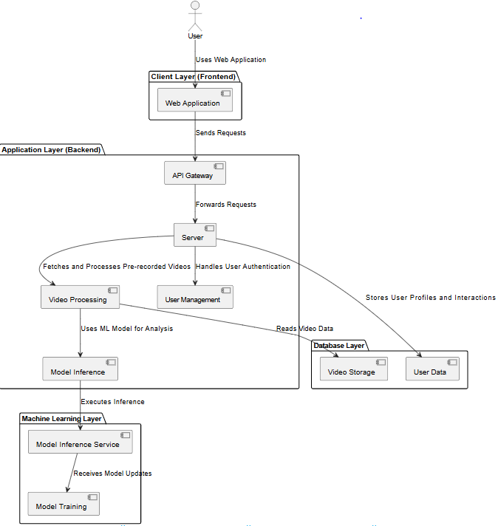

#### 12. Design Strategy

1. SpinMaster is architected using a modular and scalable design, allowing for easy incorporation of new features and improvements. Each module—such as the AI engine, feedback system, and user interface—is developed independently with well-defined interfaces. This structure enables developers to introduce enhancements like advanced analytics, support for additional racket sports, or expanded training libraries without disrupting the core system.
2. The architecture emphasizes reusability by separating concerns into distinct layers. Core components like the shot detection algorithm, pose-to-CSV converter, and performance feedback engine can be reused or repurposed for related sports analysis tools or integrated into third-party platforms with minimal adjustments.
3. SpinMaster’s user interface is designed around familiar UI/UX principles to ensure accessibility for both tech-savvy and non-technical users. It features a dark theme, modern layout, and responsive design to provide a consistent experience across devices. Clear navigation, visual feedback, and minimal interaction steps enhance usability and reduce user friction.
4. The system supports concurrent usage by handling multiple video uploads and analyses simultaneously. Proper synchronization ensures data integrity and prevents race conditions or performance degradation during high-traffic periods. This is especially critical when multiple users interact with the platform in real time, such as during tournaments or training sessions.

#### 13. Detailed System Design

5.8 Design Class Diagram



5.9 Database Design

#### ER Diagram

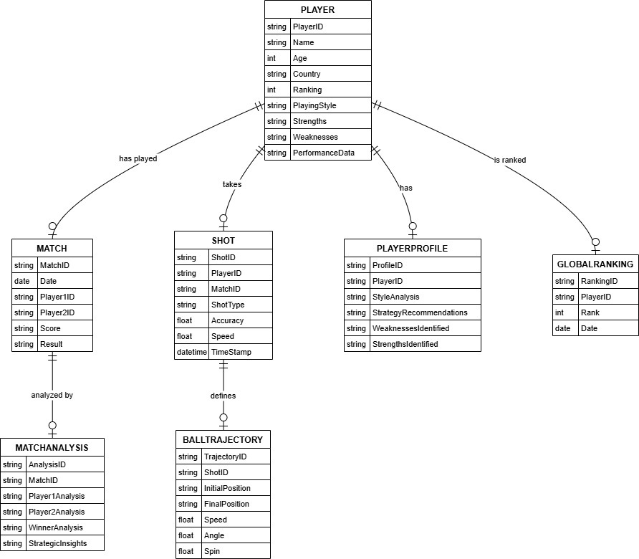

#### Data Dictionary

|  |  |
| --- | --- |
| Match | |
| **Name** | MATCH. |
| **Alias** | matches. |
| **Where-used/how-used** | Used in PLAYER, SHOT, MATCH_ANALYSIS |
| **Content description** | Contains information about all players in the system. |

|  |  |  |  |  |  |  |
| --- | --- | --- | --- | --- | --- | --- |
| **Column Name** | **Description** | **Type** | **Length** | **Null able** | **Default Value** | **Key Type** |
| Match_ID | Unique identifier for each match | String | 10 | No | (Auto-generated) | Primary Key |
| Date | Date of the match | Date | 8 | No |  |  |
| Player1ID | ID of the first player | String | 10 | No |  | FK (references Player_ID in PLAYER) |
| Player2ID | ID of the second player | String | 10 | No |  | FK (references Player_ID in PLAYER) |
| Score | Match score (e.g., 3-1) | String | 10 | No | 0 |  |
| Result | Outcome of the match (e.g., Win, Loss) | String | 10 | No |  |  |

|  |  |
| --- | --- |
| Shot | |
| **Name** | SHOT. |
| **Alias** | shots. |
| **Where-used/how-used** | Used in PLAYER, BALL_TRAJECTORY |
| **Content description** | Contains information about each shot played during a match. |

|  |  |  |  |  |  |  |
| --- | --- | --- | --- | --- | --- | --- |
| **Column Name** | **Description** | **Type** | **Length** | **Null able** | **Default Value** | **Key Type** |
| Shot_ID | Unique identifier for each shot | String | 10 | No | (Auto-generated) | Primary Key |
| Player_ID | ID of the player who took the shot | Date | 10 | No |  | FK (references Player_ID in PLAYER) |
| Match_ID | ID of the match the shot was played in | String | 10 | No |  | FK (references Match_ID in MATCH) |
| Shot type | Type of shot (e.g., Forehand, Backhand, Serve) | String | 20 | No |  |  |
| Accuracy | Accuracy of the shot (e.g., percentage) | Float | 5,2 | Yes | 0 |  |
| Speed | Speed of the shot | Float | 5,2 | Yes | 0 |  |
| Time stamp | Timestamp of the shot | Timestamp | 23 | No |  |  |

|  |  |
| --- | --- |
| PLAYER_PROFILE | |
| **Name** | PLAYER_PROFILE |
| **Alias** | Player profiles. |
| **Where-used/how-used** | Used in PLAYER |
| **Content description** | Contains detailed information about a player's profile. |

|  |  |  |  |  |  |  |
| --- | --- | --- | --- | --- | --- | --- |
| **Column Name** | **Description** | **Type** | **Length** | **Null able** | **Default Value** | **Key Type** |
| Profile_ID | Unique identifier for each player profile | String | 10 | No | (Auto-generated) | Primary Key |
| Player_ID | ID of the player associated with the profile | String | 10 | No |  | FK (references Player_ID in PLAYER) |
| Style Analysis | Analysis of the player's playing style | Text | (variable) | Yes |  |  |
| Strategy  Recommendations | Recommended strategies for the player | Text | (variable) | Yes |  |  |
| Weaknesses  Identified | Identified weaknesses of the player | Text | (variable) | Yes | 0 |  |
| Strengths  Identified | Identified strengths of the player | Text | (variable) | Yes | 0 |  |

|  |  |
| --- | --- |
| GLOBAL_RANKING | |
| **Name** | GLOBAL_RANKING |
| **Alias** | Global Rankings. |
| **Where-used/how-used** | Used in PLAYER. |
| **Content description** | Contains information about a player's global ranking. |

|  |  |  |  |  |  |  |
| --- | --- | --- | --- | --- | --- | --- |
| **Column Name** | **Description** | **Type** | **Length** | **Null able** | **Default Value** | **Key Type** |
| Ranking_ID | Unique identifier for each player profile | String | 10 | No | (Auto-generated) | Primary Key |
| Player_ID | ID of the player associated with the ranking | String | 10 | No |  | FK (references Player_ID in PLAYER) |
| Rank | Current global ranking of the player | Integer | 5 | No |  |  |
| Date | Date of the ranking | Date | 8 | No |  |  |

#### 14. Application Design

5.10 Sequence Diagram

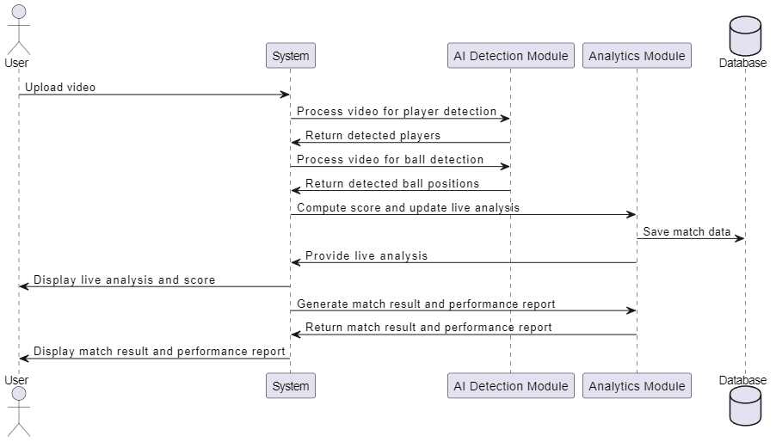

5.11 UseCase Diagram



5.12 State Diagram

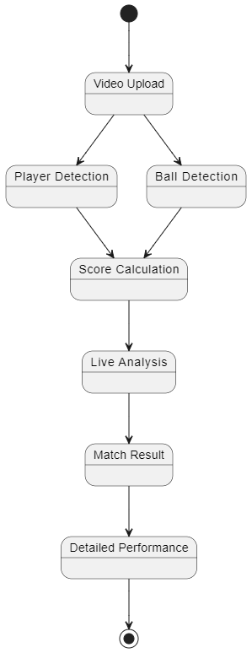

## APPENDIX D. OTHER TECHNICAL DETAIL DOCUMENTS

#### 1. Test Cases Document Test Case 1

Title: Detailed testing of this login page

|  |  |  |  |  |  |
| --- | --- | --- | --- | --- | --- |
| **S. No** | **Steps** | **Input Data** | **Expected Result** | **Actual**  **Result** | **Pass/Fail** |
| **1** | Open the login page | - | Login form displays correctly | Login form loaded as expected | Pass |
| **2** | Enter email and password | Valid credentials | Input fields accept data | Data entered successfully | Pass |
| **3** | Click the  Login button | - | User is redirected to dashboard | User redirected to dashboard | Pass |
| **4** | Verify dashboard | - | Welcome message | Welcome “username” displayed | Pass |

#### Test Case 2

Title: Detailed testing of the registration page.

|  |  |  |  |  |  |
| --- | --- | --- | --- | --- | --- |
| **S. No** | **Steps** | **Input Data** | **Expected Result** | **Actual**  **Result** | **Pass/Fail** |
| **1** | Open the registration page | - | Registration form loads | Form loaded successfully | Pass |
| **2** | Fill in registration details | Valid name, email, password | Fields accept data | Data accepted | Pass |
| **3** | Submit the form | - | User account created | Account created successfully | Pass |
| **4** | Attempt login with new creds | New email/password | User logs in successfully | Login successful | Pass |

#### Test Case 3

Title: Verify Home Page functionality.

|  |  |  |  |  |  |
| --- | --- | --- | --- | --- | --- |
| **S. No** | **Steps** | **Input Data** | **Expected Result** | **Actual**  **Result** | **Pass/Fail** |
| **1** | Log in to application | Valid credentials | Homescreen loads | Homescreen loaded | Pass |
| **2** | Upload Video for Analysis | Video Uploaded | Uploading | Loading Circle | Pass |
| **3** | Press Analyze Video | - | Feedback | Feedback + Suggested Videos | Pass |

#### Test Case 4

Title: Verify Training Modules.

|  |  |  |  |  |  |
| --- | --- | --- | --- | --- | --- |
| **S. No** | **Steps** | **Input Data** | **Expected Result** | **Actual**  **Result** | **Pass/Fail** |
| **1** | Navigate to Training Modules | - | Lots of Training Cards | Gallery of Training Modules | Pass |
| **2** | Scrolling through the cards | - | Scroll over the gallery | Easy Scrolling | Pass |
| **3** | Click on a Module | - | Video Loads | Video Hyperlinks to new tab | Pass |
| **4** | Watch another Module | - | Seamless training explanation | Seamless training explanation | Pass |

#### Test Case 5

Title: Detailed testing of Leaderboard Page

|  |  |  |  |  |  |
| --- | --- | --- | --- | --- | --- |
| **S. No** | **Steps** | **Input Data** | **Expected Result** | **Actual**  **Result** | **Pass/Fail** |
| **1** | Click on “Leaderboard” option on Navigation | - | World’s Top Ranked Players Card | Players Point Load | Pass |
| **2** | Check Player’s Point | - | Show Professional Player’s Points | Shows the points | Pass |
| **3** | Scroll and Hover over players | - | Show details of players | Shows detail with little animation | Pass |

#### 2. UI/UX Detail

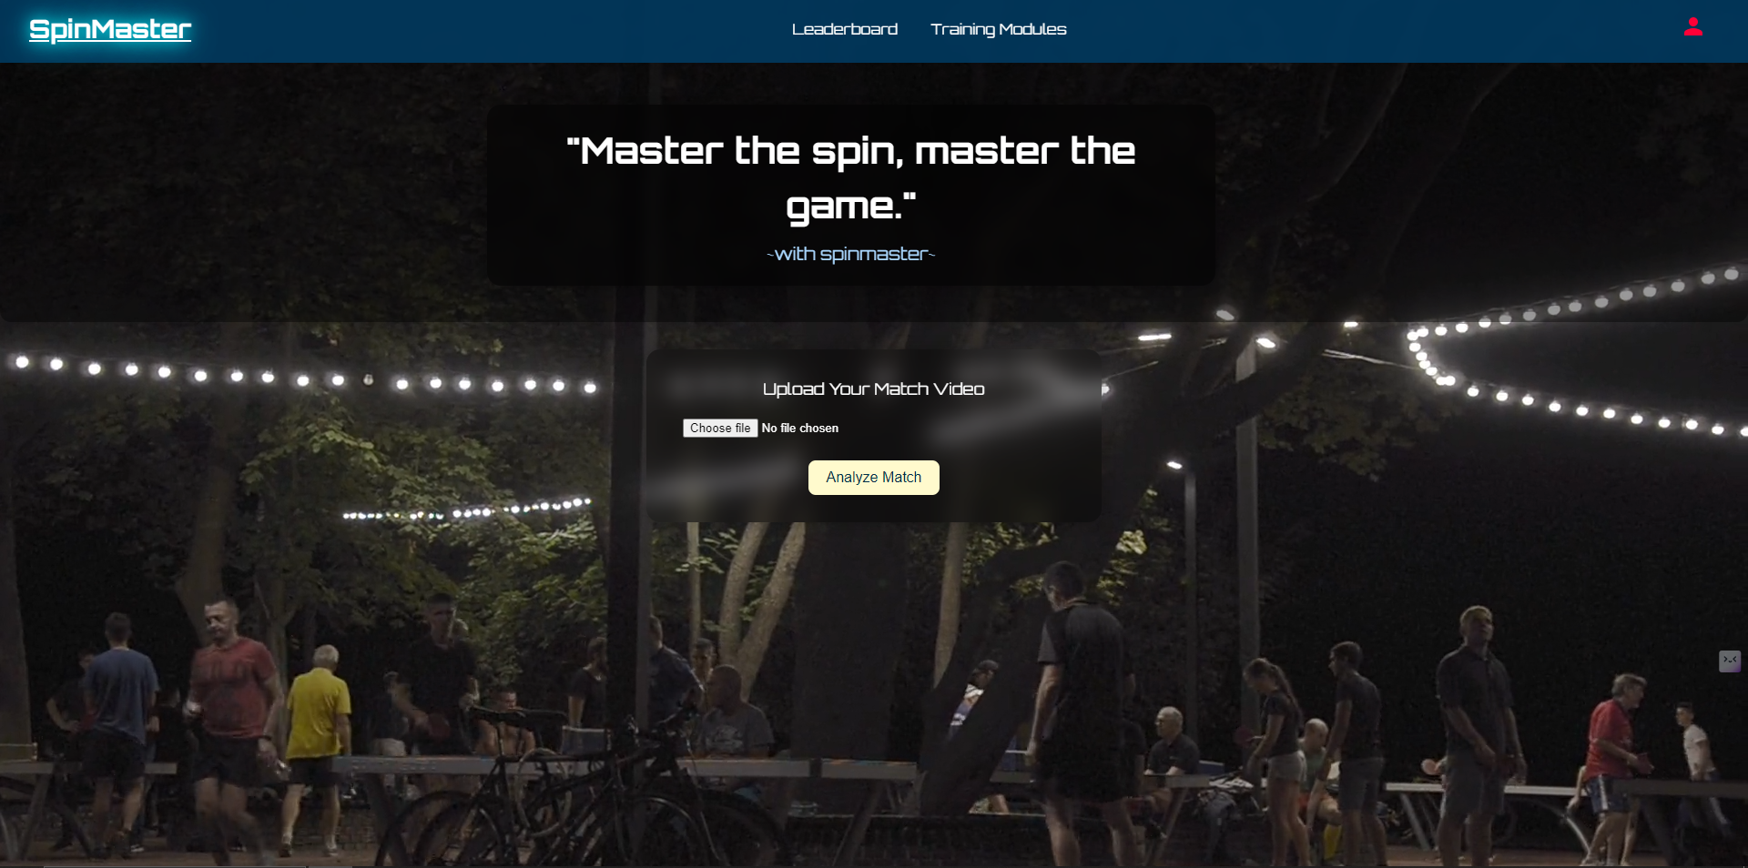

Figure 12-1 Application UI-1

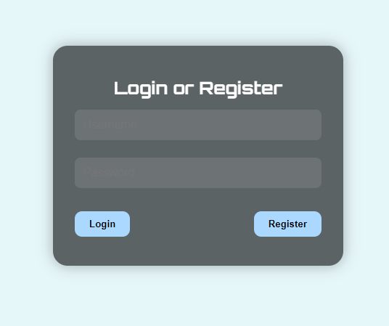

Figure 13-2 Application UI-2

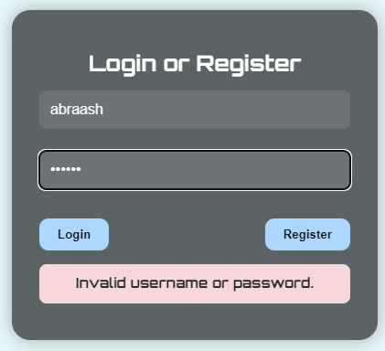

Figure 14-3 Application UI-3

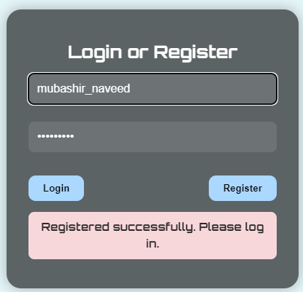

Figure 15-4 Application UI-4

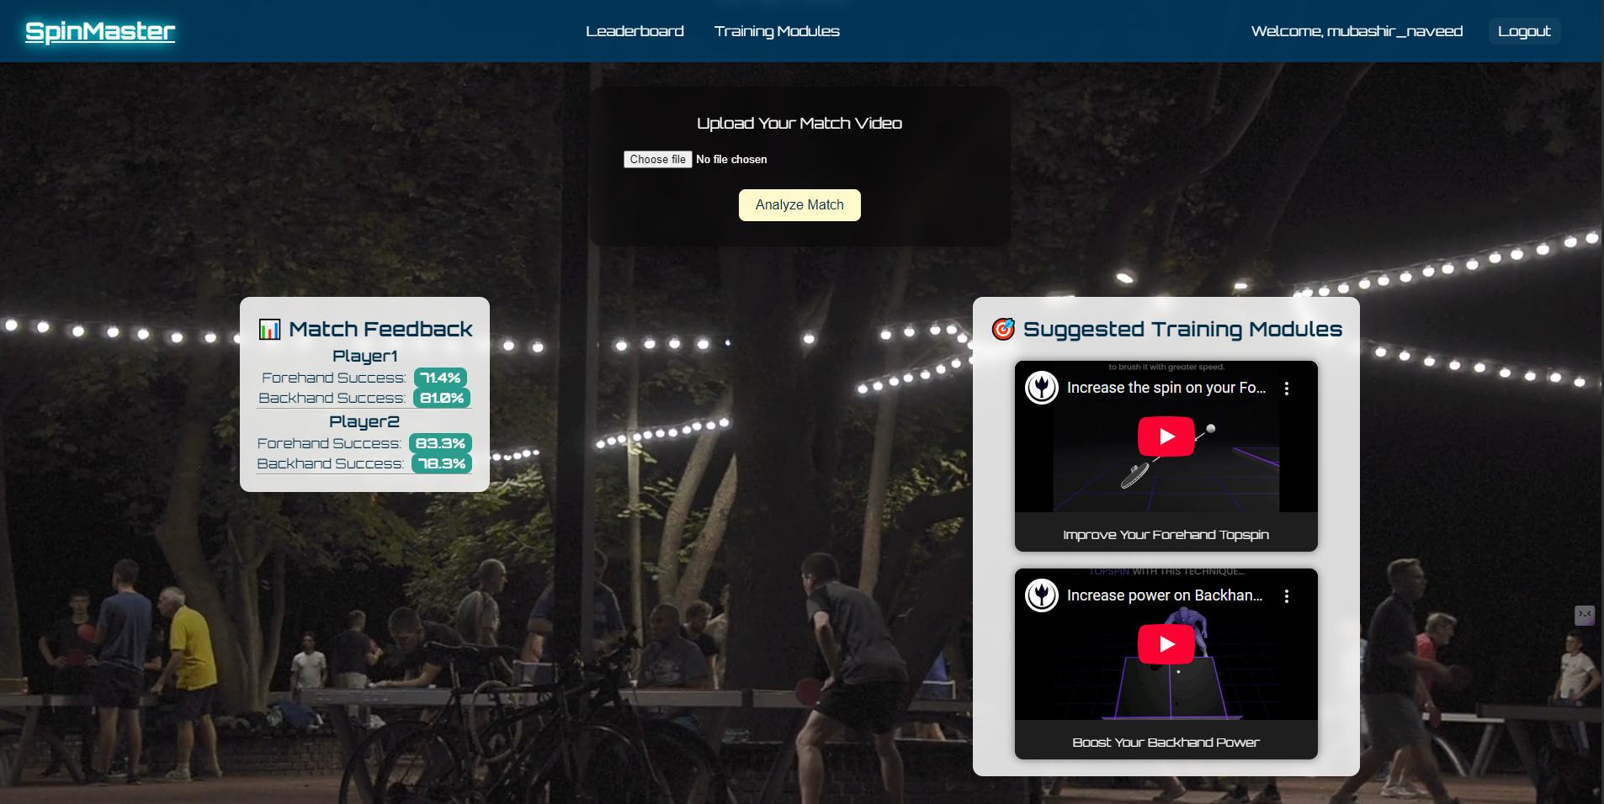

Figure 16 Application UI-5

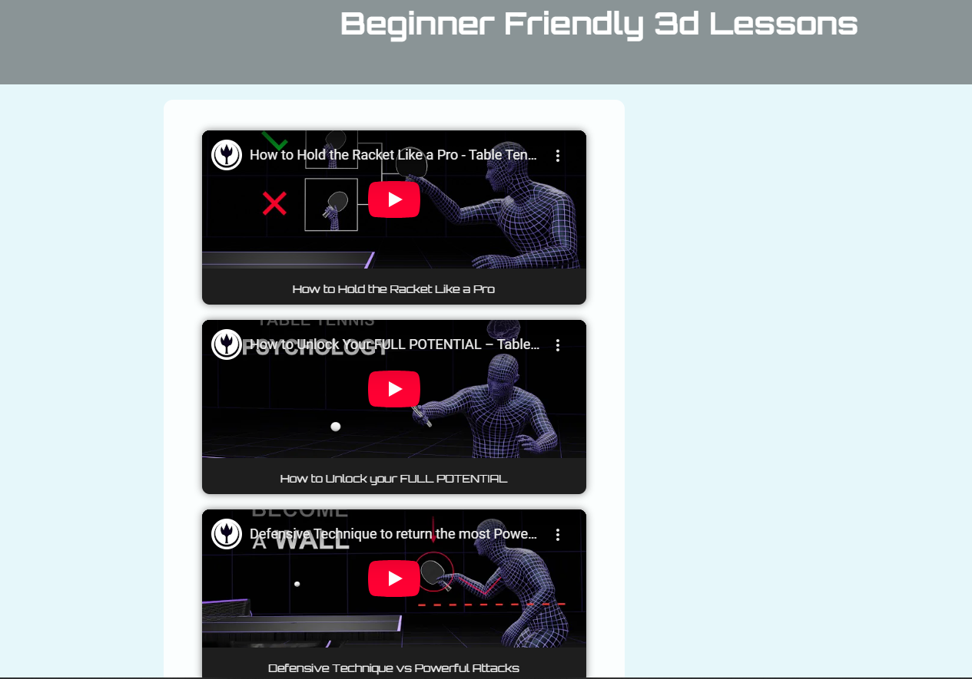

Figure 17 Application UI-6

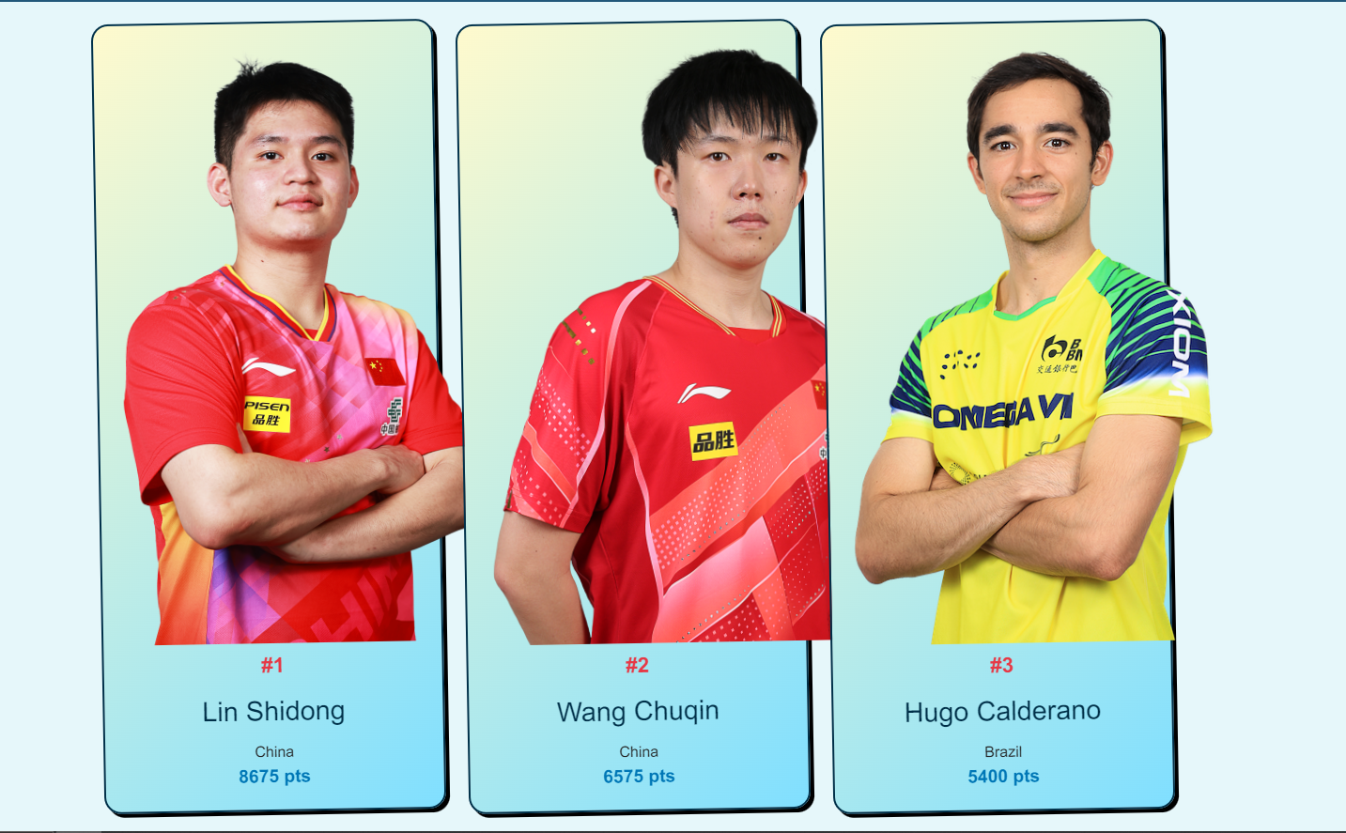

Figure 18 Application UI-7

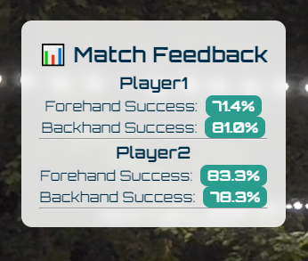

Figure 19 Application UI-8

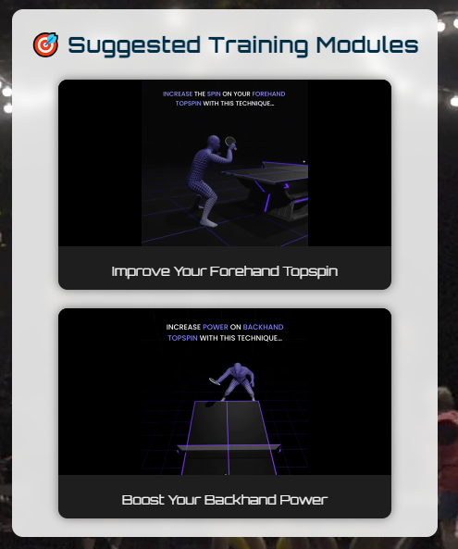

Figure 20 Application UI-9

#### 3. Coding Standards

To maintain readability, consistency and long-term maintainability of the Plant Disease Detection, standard coding practices were strictly followed throughout the development process. These standards ensured that the source code was clean, well-organized and easily understandable by any developer or contributor.

* Meaningful name: Meaningful name should be used to clearly define the purpose.
* Modularity: Code is organized into reusable function instead of inline blocks.
* Commenting: Inline comments were added to explain complex logic, and function headers included docstrings to describe inputs, outputs, and purposes. This made the code base easier to understand and maintain.
* Consistency: consistent formatting, spacing and indentation used throughout.
* Version Control: GitHub was used for version control to manage the code changes and maintain the history of development progress.

## APPENDIX E. FLYER & POSTER DESIGN

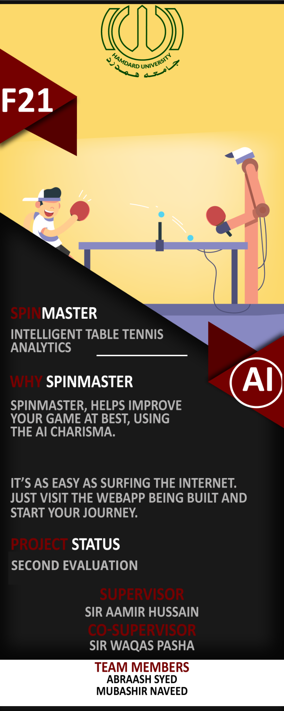

Figure 21 Flyer and Poster Design

## APPENDIX F. COPY OF EVALUATION COMMENTS BY JURY FOR PROJECT – I



## APPENDIX G User Manual Document

#### 1. User Manual Document

This user guide is intended for table tennis players and general users to operate the **SpinMaster** mobile application. The app analyzes gameplay videos using image processing and AI-powered shot classification to detect weaknesses in forehand, backhand, footwork, and overall strategy. After analysis, it provides users with performance insights and tailored training recommendations, including downloadable PDF reports for future reference.

#### 2. Starting the Application

Once the website is running on your device:

* Locate the login option on nav bar.
* Click to open the login form..

#### 3. Using the Model, Step – by – Step

#### Step 1: Sign Up/Login

* Tap **“Sign Up”** to create a new account by entering your username, email, and password.
* If you’re a returning user, tap **“Login”** and enter your credentials to access your dashboard.
* Upon successful login, you'll be directed to the **Home Screen**.

#### Step 2: Upload Match Video

Once you have logged in, You will see a button.

* Upload Video: Choose a previously recorded match from your gallery.

Ensure that:

* The camera angle captures both players.
* The lighting is sufficient.
* The full table and player movements are visible.

#### Step 3: Start Analysis

Once a video is selected, press the “Analyze Game” button.

The model processes the footage using its trained AI model and after a few seconds displays:

* Player performance statistics.
* Weakness detection (e.g., weak backhand, late footwork).
* Overall win/loss metrics.

#### Step 4: View Feedback / Insights

Feedback may include:

* Inconsistent backhand returns.
* Poor positioning on high balls.
* Missed forehand smashes.

#### Step 5: Recommendation for Treatment

Based on detected issues, the app will show links to training modules (e.g., YouTube tutorials).

Training suggestions are tailored and may focus on:

* Stroke mechanics.
* Spin control.
* Agility and footwork drills.

#### 4. Troubleshooting Tips

Here are some typical problems users might run into when utilizing the web, along with easy fixes:

Issue: Unable to Upload Video

* Ensure the app has permission to access your media files.
* Check video format compatibility (.mp4 preferred).

Issue: Analysis Not Responding

* Verify that your internet connection is active.
* Restart the app and try uploading again.

Issue: Login Failed

* Double-check your email and password.
* Use the “Forgot Password” option if needed.